
Maryland State Department of Education
Service-Learning Units
Aligned with the
Maryland State Curriculum

Unit Title | Primary  Subject Area | Additional Subject Areas | Grade(s) | Type of Service-Learning Action
1. Animals in World  Cultures | Language Arts | Social Studies, Art | 7th | Indirect and/or Advocacy
2. Assisting Senior  Citizens with  Computers | Computer Technology & Business Education | Language Arts | 8th - 12th | Direct
3. Bullying | Health | Science, Math, Language Arts | 6th | Advocacy
4. Casey Cares –  Helping Critically  Ill Children | Reading and Language Arts | Art, Math, Social Studies, Science, Health | 8th | Indirect and/or Advocacy
5. Disability  Awareness/Health  Fair | Reading and Language Arts | Visual Arts, Health, Math | 6th | Indirect and/or Advocacy
6. Lobbying Public  Issues | Social Studies | Language Arts | 9th or 10th | Advocacy
7. My Place in History | Reading and Language Arts | Visual Arts | 7th | Direct, Indirect, and/or advocacy
8. Native Species  Restoration | Science/Ecology | Math, Technology, Engineering, Language Arts | 7th | Direct and/or Indirect
9. Natural Disasters | Science (Earth & Space Science) | Health | 8th | Direct, Indirect and/or advocacy
10. Nutrition and  Fitness | Health | Math, Science, Language Arts | 6th and/or 7th | Indirect and/or Advocacy
11. Read to Feed | Social Studies | Math, Language Arts, Science | 7th | Indirect
12. Read to Me | Reading and Language Arts | Math, Visual Arts | 6th-8th | Direct, Indirect, and/or Advocacy
13. Reducing Energy  Consumption | Science/Physics | Social Studies | 6th and/or 7th | Advocacy
14. Special Olympics | Health/PE | Language Arts, Visual Arts | High School | Indirect and/or Direct
15. Supporting  America’s Military | Social Studies | Language Arts, Math | 8th | Indirect

Maryland State Department of Education

Service-Learning Units
Aligned with the Maryland State Curriculum:
Subject Connection Table

Service-Learning  Unit Title | Engineering | Health | RLA | Math | Science | Social Studies | Technology | Visual Arts
Animals in World Cult.
Assist Senior Citizens
Bullying
Casey Cares-Ill Children
Disability/Health Fair
Lobbying Public Issues
My Place in History
Native Species Restor.
Natural Disasters
Nutrition & Fitness
Read to Feed
Read to Me
Reducing Energy Cons.
Special Olympics
Support US Military
- Created July 2007

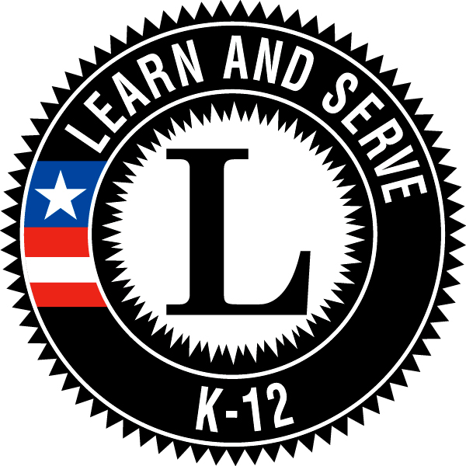
This material is based upon work supported by the Corporation for National and Community Service under the Learn and Serve America Grant No. 06KSAMD001. Opinions or points of view expressed in this document are those of the authors and do not necessarily reflect the official position of the Corporation or the Learn and Serve America Program.

Maryland State Department of Education

Service-Learning Units
Aligned with the Maryland State Curriculum:
Grade Level Connection Table

Service-Learning  Unit Title | 6th | 7th | 8th | 9th | 10th | 11th | 12th
Animals in World Cult.
Assist Senior Citizens
Bullying
Casey Cares-Ill Children
Disability/Health Fair
Lobbying Public Issues
My Place in History
Native Species Restor.
Natural Disasters
Nutrition & Fitness
Read to Feed
Read to Me
Reducing Energy Cons.
Special Olympics
Support US Military
- Created July 2007

This material is based upon work supported by the Corporation for National and Community Service under the Learn and Serve America Grant No. 06KSAMD001. Opinions or points of view expressed in this document are those of the authors and do not necessarily reflect the official position of the Corporation or the Learn and Serve America Program.

