Division of Early Intervention and Special Education Services
Birth to K PARTNERS ADVISORY
BUILDING BRIDGES

A STATEWIDE PUBLIC SERVICE AWARENESS PROGRAM
January 20, 2021
The Maryland State Department of Education (MSDE), Division of Early Intervention and Special Education Services (DEI/SES) has partnered with The Johns Hopkins University School of Education IDEALS Institute to develop a NEW public service awareness program to promote awareness of early intervention and preschool special education services that are available to families of children in Maryland - from birth to kindergarten - through the DEI/SES Maryland Infants and Toddlers Program and Preschool Special Education Services. We need your support to reach families with the following message:
If you have questions about your child’s development, get help early. Don’t lose time waiting to see if a concern “goes away” — delays and/or disabilities are more likely to be minimized or resolved when they’re addressed early. Take the first step to determine if your child qualifies for services. Text CHILD to 818818.

Some suggested ways you can help to spread the word about the availability of early intervention and preschool special education services are:
- Send an email blast to your networks of families, family support service coordinators, educators, administrators, and community partners. Include the link to our Family Resources.
- Post Building Bridges content to your social media networks: Twitter, Instagram, Facebook. Use the hashtags:
- Embed the Building Bridges public service announcements (PSA) – or provide a link to the videos - on your website
- Send a flyer or hang a flyer in a location accessible to families, educators and providers.
Use our Template for DEI/SES Publicity Partners to get started. To make it easy for our local and State partners to participate, we’re providing a Template for DEI/SES Publicity Partners (below), which includes general information, sample social media posts, logos, images, and links to share or embed the PSA videos. We hope you will join us to support children and families in Maryland. If you have questions, please contact Janette Guerra, DEI/SES Early Childhood Section Chief, at janette.guerra@maryland.gov.
TEMPLATE FOR DEI/SES PUBLICITY PARTNERS
General Messaging, Social Media Samples, Images, Logos, Fylers
BUILDING BRIDGES
STATEWIDE PUBLIC SERVICE AWARENESS PROGRAM
MARYLAND STATE DEPARTMENT OF EDUCATION
DIVISION OF EARLY INTERVENTION AND SPECIAL EDUCATION SERVICES (DEI/SES)
&
THE JOHNS HOPKINS UNIVERSITY SCHOOL OF EDUCATION IDEALS INSTITUTE

GENERAL MESSAGING
A child’s early experiences can profoundly influence how their brains will develop and how they interact with others, learn and participate in daily activities, and use appropriate behaviors to get their needs met. As a parent or caregiver, trust your instincts and how well you know your child. If you have questions about your child’s development, get help early. Don’t lose time waiting to see if a concern “goes away” — delays and/or disabilities are more likely to be minimized or resolved when they’re addressed early. Take the first step to determine if your child qualifies for services. Text CHILD to 818818.
Find more information at marylandlearninglinks.org/what-do-i-do-next.
SOCIAL MEDIA HASHTAGS
#BuildingBridgesMD
#Birthto5Md
#Infants_Toddlers_Preschoolers
SAMPLE TWEETS
- Families know their children best. If you have questions or concerns, take the first step to see if your child qualifies for services. Text CHILD to 818818 or visit marylandlearninglinks.org/what-do-i-do-next. #BuildingBridgesMD #Birthto5Md #Infants_Toddlers_Preschoolers
- Concerned about how your young child is learning and interacting with others? Your child may qualify for services at no cost to your family. Text CHILD to 818818 or visit marylandlearninglinks.org/what-do-i-do-next. #BuildingBridgesMD #Birthto5Md #Infants_Toddlers_Preschoolers
- Questions about your child’s development? The years between birth and kindergarten are such an important time. Don’t wait to get help. Text CHILD to 818818 or visit http://bit.ly/2KquBrN #BuildingBridgesMD #Birthto5Md #Infants_Toddlers_Preschoolers
SAMPLE POSTS FOR INSTAGRAM, FACEBOOK, etc.
- Families know their children best. If you’re having any questions about your young child’s development, don’t wait. Take the first step to see if your child qualifies for services that can help. Text CHILD to 818818 or visit marylandlearninglinks.org/what-do-i-do-next. #BuildingBridgesMD #Birthto5Md #Infants_Toddlers_Preschoolers
- Are you concerned about how your young child is learning and interacting with others? Your child may qualify for services at no cost to your family. And by starting early, you can make a big difference in helping your child reach their potential. Watch this video about starting early or Text CHILD to 818818. #BuildingBridgesMD #Birthto5Md #Infants_Toddlers_Preschoolers https://marylandlearninglinks.org/what-do-i-do-next/
- The years between birth and kindergarten are such an important time for child development. If you have questions about your child’s development, don’t wait. All local Early Intervention and Preschool Special Education programs are open and provide services at no cost to your family. Text CHILD to 818818. #BuildingBridgesMD #Birthto5Md #Infants_Toddlers_Preschoolers https://marylandlearninglinks.org/what-do-i-do-next/
eBLAST COPY FOR EMAILS, WEBSITES AND BLOGS
The years between birth and kindergarten are such an important time for child development.
They are growing, playing, learning, and getting ready for school and later success in life—all at a faster rate than any other time. While all children develop at different rates, some young children experience delays in their development.
Families are critical to children’s development and know their children best. If you’re having any concerns about how your child is interacting with others, learning, and participating in daily activities or using appropriate behaviors for getting needs met– don’t wait.
Take the first step to determine if your child qualifies for services. Text CHILD to 818818.
All local Early Intervention and Preschool Special Education programs are open and conducting evaluations and providing services. All services are provided at no cost to your family. By starting early, you can make a big difference in helping your child reach his potential.
Find more information at marylandlearninglinks.org/what-do-i-do-next.
HTML CODE FOR EMBEDDING THE PUBLIC SERVICE ANNOUNCEMENT VIDEOS ON YOUR AGENCY WEBSITE/BLOG
- Video 1, Early Intervention: <iframe width="560" height="315" src="https://www.youtube.com/embed/MqLEP1m8Drc" frameborder="0" allow="accelerometer; autoplay; clipboard-write; encrypted-media; gyroscope; picture-in-picture" allowfullscreen></iframe>
- Video 2, Early Intervention: <iframe width="560" height="315" src="https://www.youtube.com/embed/BfR5QXSFo6I" frameborder="0" allow="accelerometer; autoplay; clipboard-write; encrypted-media; gyroscope; picture-in-picture" allowfullscreen></iframe>
- Video 3, Early Intervention: <iframe width="560" height="315" src="https://www.youtube.com/embed/ruxqmkUGlPU" frameborder="0" allow="accelerometer; autoplay; clipboard-write; encrypted-media; gyroscope; picture-in-picture" allowfullscreen></iframe>
- Video 4, Early Intervention: <iframe width="560" height="315" src="https://www.youtube.com/embed/10T0KZNMie8" frameborder="0" allow="accelerometer; autoplay; clipboard-write; encrypted-media; gyroscope; picture-in-picture" allowfullscreen></iframe>
FLYERS FOR FAMILIES & CHILD CARE PROVIDERS
- Download printable flyers for Families and Child Care Providers
BUILDING BRIDGES FAMILY RESOURCES WEBSITE
- https://marylandlearninglinks.org/what-do-i-do-next/
- Tiny URL: http://bit.ly/2KquBrN
AGENCY LOGOS

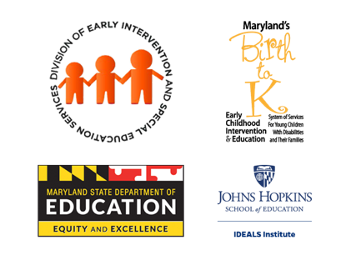
grouped -logos_b.png
grouped-logos_a.png

IMAGES
Twitter Images
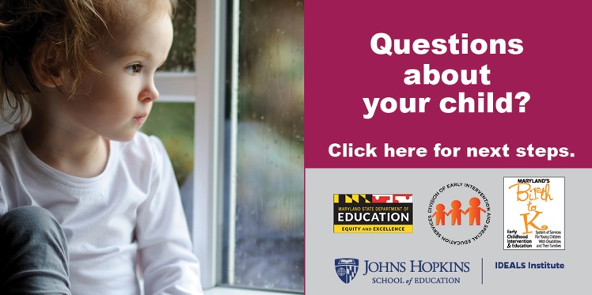
Tweet-image-1.png
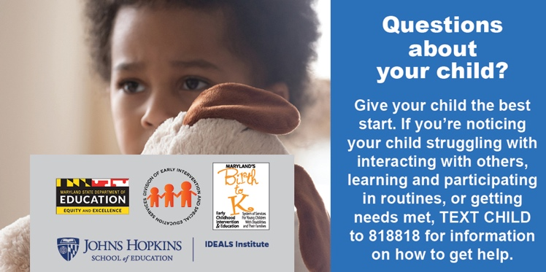
Tweet-image-2.png
Facebook Images
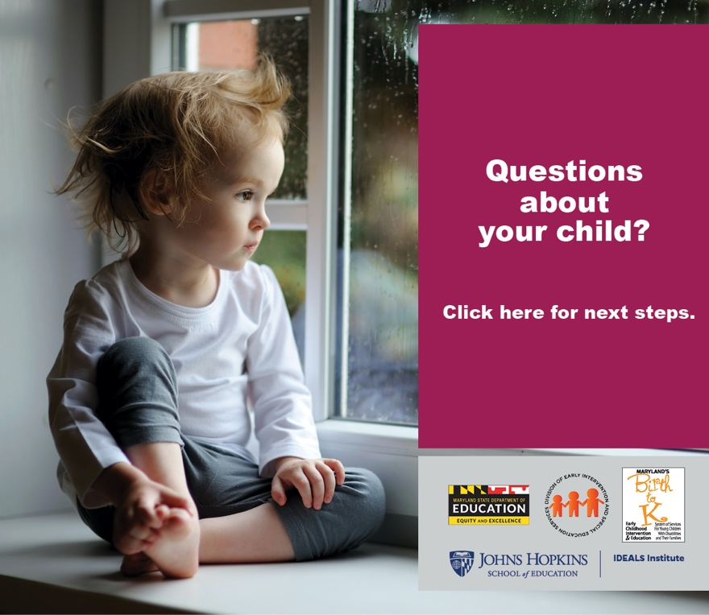
Facebook-image-1.png
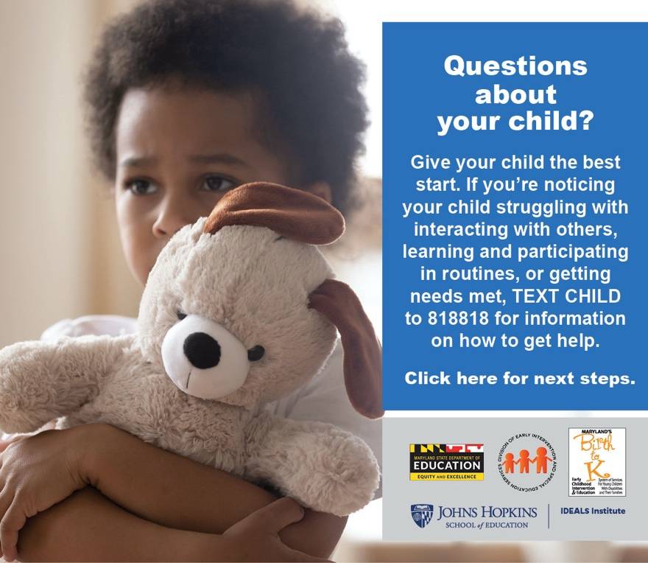
Facebook-image-2.png
eBlast Images
eBlast-image-1.png
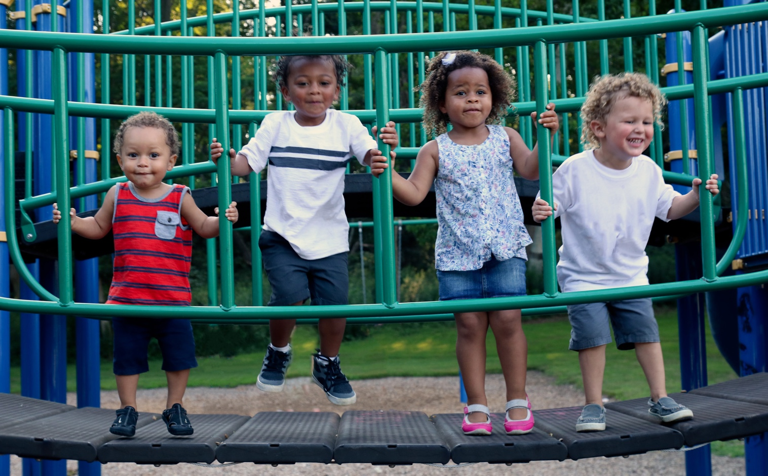
eBlast-image-2.png
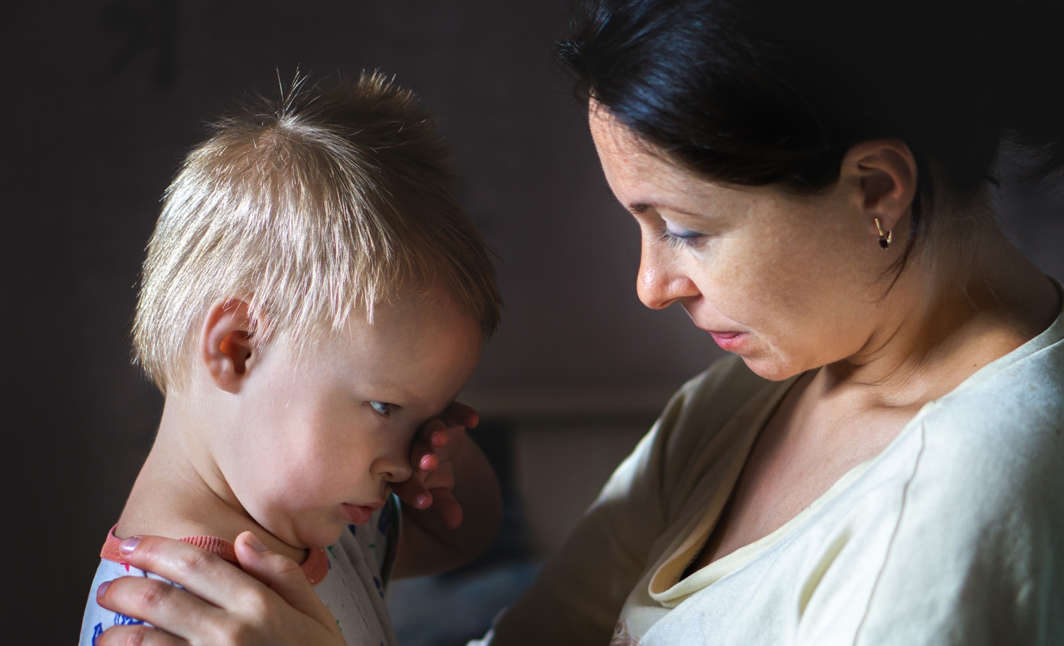eBlast-image-3.png
eBlast-image-4.png
BUILDING BRIDGES
STATEWIDE PUBLIC SERVICE AWARENESS PROGRAM
CONTACT INFORMATION
Janette Guerra
Section Chief for Early Childhood
Performance Support and Technical Assistance Branch
Maryland State Department of Education
Division of Early Intervention and Special Education Services
200 West Baltimore Street
Baltimore, Maryland 21201
janette.guerra@maryland.gov
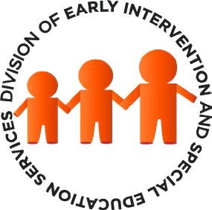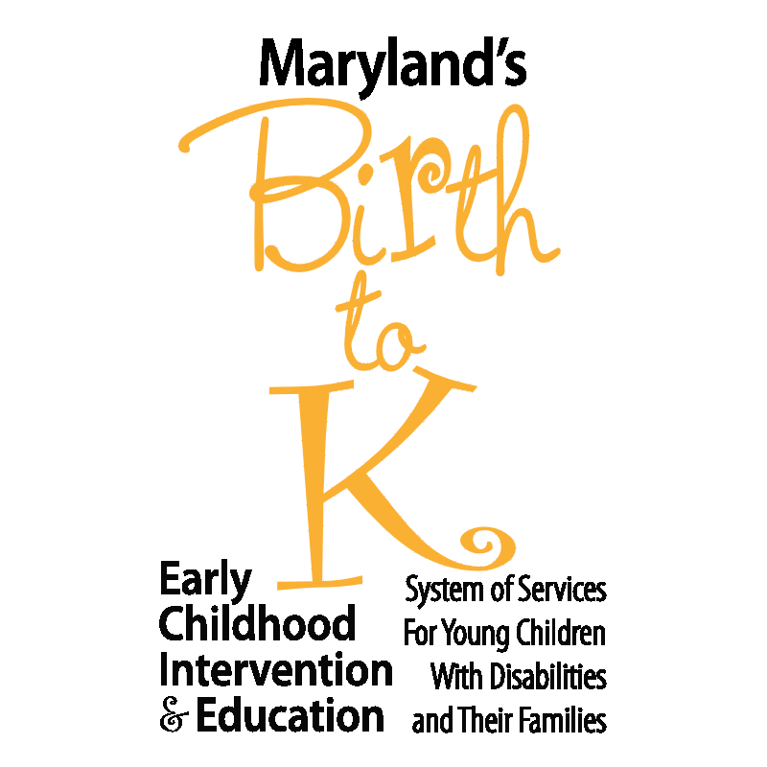

© 2021 Maryland State Department of Education
Produced under the guidance of Marcella E. Franczkowski, Assistant State Superintendent, Division of Early Intervention and Special Education Services. Please include reference to the Maryland State Department of Education, Division of Early Intervention and Special Education Services on any replication of this information. To request permission for any use that is not “fair use” as that term is understood in copyright law, contact: Maryland State Department of Education, Division of Early Intervention and Special Education Services, 200 West Baltimore Street, Baltimore, Maryland 21201, 410-767-0249 voice.

Karen B. Salmon, Ph.D.
State Superintendent of Schools

Clarence C. Crawford
President, Maryland State Board of Education

Larry Hogan
Governor

Carol A. Williamson, Ed.D.
Deputy State Superintendent for Teaching and Learning

Marcella E. Franczkowski, M.S.
Assistant State Superintendent
Division of Early Intervention and Special Education Services

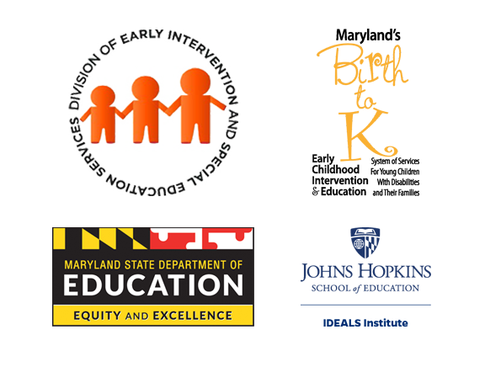
200 West Baltimore Street
Baltimore, Maryland 21201
MarylandPublicSchools.org

