Technical Assistance Bulletin
Division of Early Intervention and Special Education Services | Bulletin # 20-06
Birth – Age 4 Birth – K Age 3 – K Birth – 21 Age 3 – 21

Date: April 2020

Continuity of the IFSP for Young Children (Birth – Age 4) with Developmental Delays/Disabilities and their Families during Extended School/Agency Closure due to the COVID-19 Pandemic

Purpose

The purpose of this Technical Assistance Bulletin (TAB #20-06) is to guide the provision for the continuity of services to young children with developmental delays/disabilities and their families during physical school/program closure made necessary by the State of Emergency Response to the COVID-19 Pandemic. This guidance remains in effect until further notice and is aligned with schools/programs resuming normal operations.

The Maryland State Department of Education, Division of Early Intervention and Special Education Services (MSDE, DEI/SES) recognizes that local school systems (LSSs) and public agencies (PAs) have rapidly shifted operations and provisions of service delivery from in-home or community-based sessions to virtual and/or distance learning. For infants, toddlers, and preschoolers with developmental delays/disabilities, continuity of services includes the provision of early intervention services to support the child's family in accordance with the Individualized Family Service Plan (IFSP) to the greatest extent possible during these unprecedented times.

Specifically, this guidance supports the development, implementation, and evaluation of agreed-upon distance service delivery designed to promote the continuity of IFSP services for young children with disabilities and their families. Several flowcharts have been created to support thought-processes for distance service delivery in addition to "Frequently Asked Questions." For additional detailed guidance to support the continuity of preschool special education services through an amended Individualized Education Program (IEP), please refer to the DEI/SES Technical Assistance Bulletin #20-03: Providing Continuity of Learning to Students with Disabilities During Extended School Closure Due to the COVID-19 Pandemic.

The Law
Under Part C of the Individuals with Disabilities Act (IDEA) and State law, eligible children with disabilities are entitled to early intervention services (EIS). EIS are designed to meet the developmental needs of an infant or toddler with a disability and to meet the needs of the family to assist appropriately in their child’s development. (34 CFR §303.13(a)(4)). These services are wide ranging to address the unique needs of the individual child, including, but not limited to, assistive technology, family training and counseling, physical therapy, occupational therapy, speech and language services, and social work services. (See COMAR 13A.13.01.03(b)).

Early Intervention Services enhance the capacity of families to meet the needs of their child with a disability by capitalizing on learning experiences that occur in everyday routines and contexts (Workgroup on Principles and Practices in Natural Environments, 2007). These services are provided within a child’s natural environment or “settings that are natural or typical for a same-aged infant or toddler without a disability,” such as home and community settings. (34 CFR §303.26). EIS must be provided, to the greatest extent appropriate, in natural environments; when the natural environment is not appropriate, the parent and the IFSP team may choose another appropriate setting. (34 C.F.R. § 303.126). Individualized distance service delivery constitutes provision of services in the natural environment.

As of the publication of this guidance, the legal obligations under IDEA remain in effect, including timelines, meeting procedures, and entitlement to services. However, health and safety concerns due to the pandemic, along with the closure of local public agencies, will impact the manner in which early intervention services are provided. To the greatest extent practicable, local public agencies and early intervention providers should consider using tele-intervention or distance service delivery methods. Upon resumption of normal operations, local public agencies will need to address whether the child requires remediation to address any decline in skills or behaviors, or lack of progress on IFSP outcomes resulting from missed services due to agency closures. For more information on the legal obligations under Part C of the IDEA (e.g., service provision, IFSP meetings, and evaluations) during agency closures, please refer to the DEI/SES Technical Assistance Bulletin #20-01 “Serving Children with Disabilities under IDEA During School Closures Due to the COVID-19 Pandemic.”

Overview: Continuity of Services During an Extended School/Agency Closure (COVID-19 Response)

The primary goals of early intervention and preschool special education services are:
- to enable all young children to be full and active participants of everyday routines and activities in their homes, schools, and communities; and
- to build the capacity of families to help their child learn, achieve developmental milestones, and participate in home and community activities.

Key features of early intervention programs required by Part C of IDEA include the utilization of family-centered services and the provision of services within a child's natural environment. Best practice recommendations demonstrate improved child and family results when service providers use coaching as the adult interaction style to build the capacity of families to support their child's meaningful participation in everyday routines and activities. This philosophy and approach are all the more applicable when early intervention providers are unable to physically join families in daily activities at home or in the community, requiring service delivery to occur remotely.

During the COVID-19 Pandemic, the highest priority must be to ensure the health and safety of children, families, and service providers, and must comply with the Governor's stay-at-home order. The discussion to develop agreed-upon service delivery does not require a formal IFSP meeting, nor does the IFSP team need to modify the online IFSP if only changes related to frequency and duration of current services are agreed upon. Details of the discussion and agreed upon distance service delivery should be clearly documented in service coordination notes/logs within the Early Intervention Record (EIR). It is important that all IFSP team members are informed of modifications to service delivery, including clearly defined roles and responsibilities prior to implementation.

Distance service delivery also aligns to the interdisciplinary and transdisciplinary teaming models recommended as best practice in early intervention. Tele-intervention can be utilized within these models to facilitate authentic assessment, collaboration, coaching, consultation, and mobilization of resources and family supports. Coaching and consultative services are used to enhance the family's capacity to embed learning opportunities within naturally occurring routines and activities. IFSP team members, including families, can work together to identify natural learning opportunities within the family's daily activities, develop strategies to embed within their routines to promote functional skills and behavior development, monitor progress towards outcomes, collaboratively problem-solve, and identify community and family resources. Regular teaming and interdisciplinary communication/coaching structures are critical to support all IFSP team members' capacity to implement distance service delivery.

System leadership is encouraged to think about the continuity of services as part of the continuum of supports and services provided to all children/families in response to the COVID-19 Pandemic. Proactive planning, meaningful parent collaboration, and good faith efforts based on the current IFSP lead the discussion to outline and identify what services will look like for children with disabilities and their families to the greatest extent possible during this unprecedented time.

Development of Individualized Distance Service Delivery for Each Child and Family

Service coordinators and/or primary service providers develop agreed-upon individualized distance service delivery with each family in order to continue providing IFSP services to the greatest extent possible. This begins with first engaging the family in an authentic and meaningful conversation about their priorities for their child and family well-being and what distance service delivery could look like, based on the current IFSP to the greatest extent possible.

TIP: Engage the family in meaningful discussions about how routines and activities have changed/been impacted by the "stay at home" order, including how their child is participating in activities, interacting with others, and using appropriate behaviors to get their wants/needs met.

Conversations are collaborative and provide an opportunity for the parent to share and discuss critical information about their daily routines and activities and how their child is participating. This includes any in-home supports as well as their own job-related time commitments and responsibilities. This information is essential for the success of any remote service delivery plan.

Individualized continuity of service delivery will reflect the agreed-upon supports, services, and methodologies that will best meet the needs of the family, considering flexibility, family priorities and needs, and available resources. This conversation is documented within service coordination/delivery notes in the EIR.

When planning for distance service delivery, consider:
- Remote methods to deliver services (telephone, online platforms, email, mail, etc.)
- Availability and accessibility of necessary technology
- A clear understanding of parent expectations
- Role of and support for parents and family members
- A clear understanding of the daily routines and activities
- Method(s) to monitor progress
- An ongoing communication system between the parent and the IFSP team
- Professional development to build service provider capacity for virtual service delivery
- Service providers that will deliver early intervention services and supports

Frequently Asked Question

Q: What happens if a family was contacted and supports and services were discussed, including offering a variety of distance methods (e.g., phone, email, videoconferencing), but the family declined services at this time?
A: While many families will agree on supports and services offered through tele-intervention, some families may decline this method of service delivery. The conversation with the family must be clearly documented in the EIR with an agreed-upon time to follow-up (i.e., at least monthly). Families who initially decline services may subsequently accept tele-intervention supports and services. Continue to make regular contact with the family and clearly document every conversation in service coordination logs/notes.

The following flowchart provides a thought-process guide as the continuity of IFSP distance service delivery is considered based on a family's current priorities and needs.

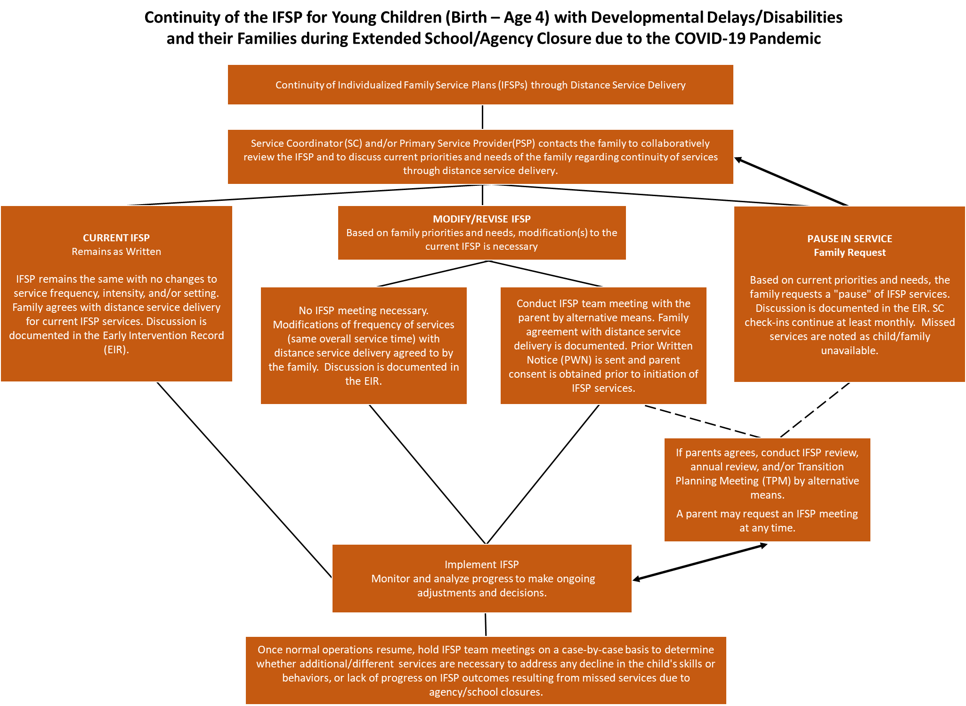

Figure 1. Continuity of the IFSP for Young Children (Birth – Age 4) with Developmental Delays/Disabilities and Their Families during Extended School/Agency Closure due to the COVID-19 Pandemic (see Appendix A for a full-size readable document).

Development of NEW Individualized Family Service Plans During the COVID-19 Pandemic

If an infant or toddler has a diagnosed condition that makes him or her automatically eligible for early intervention services, with parent consent, a review of medical and other records can and may be completed to establish eligibility without conducting an evaluation of the child (refer to MITP Individualized Family Service Plan Process and Document Guide, page 11). Additionally, with parent consent, an evaluation for eligibility can be completed using distance methodologies and following administration protocols, when the evaluation includes all developmental domains and yields the necessary scoring to determine if the child has a 25% delay in at least one area or atypical development.

The flowchart below highlights considerations for IFSP development activities for NEW referrals during the COVID-19 Pandemic:

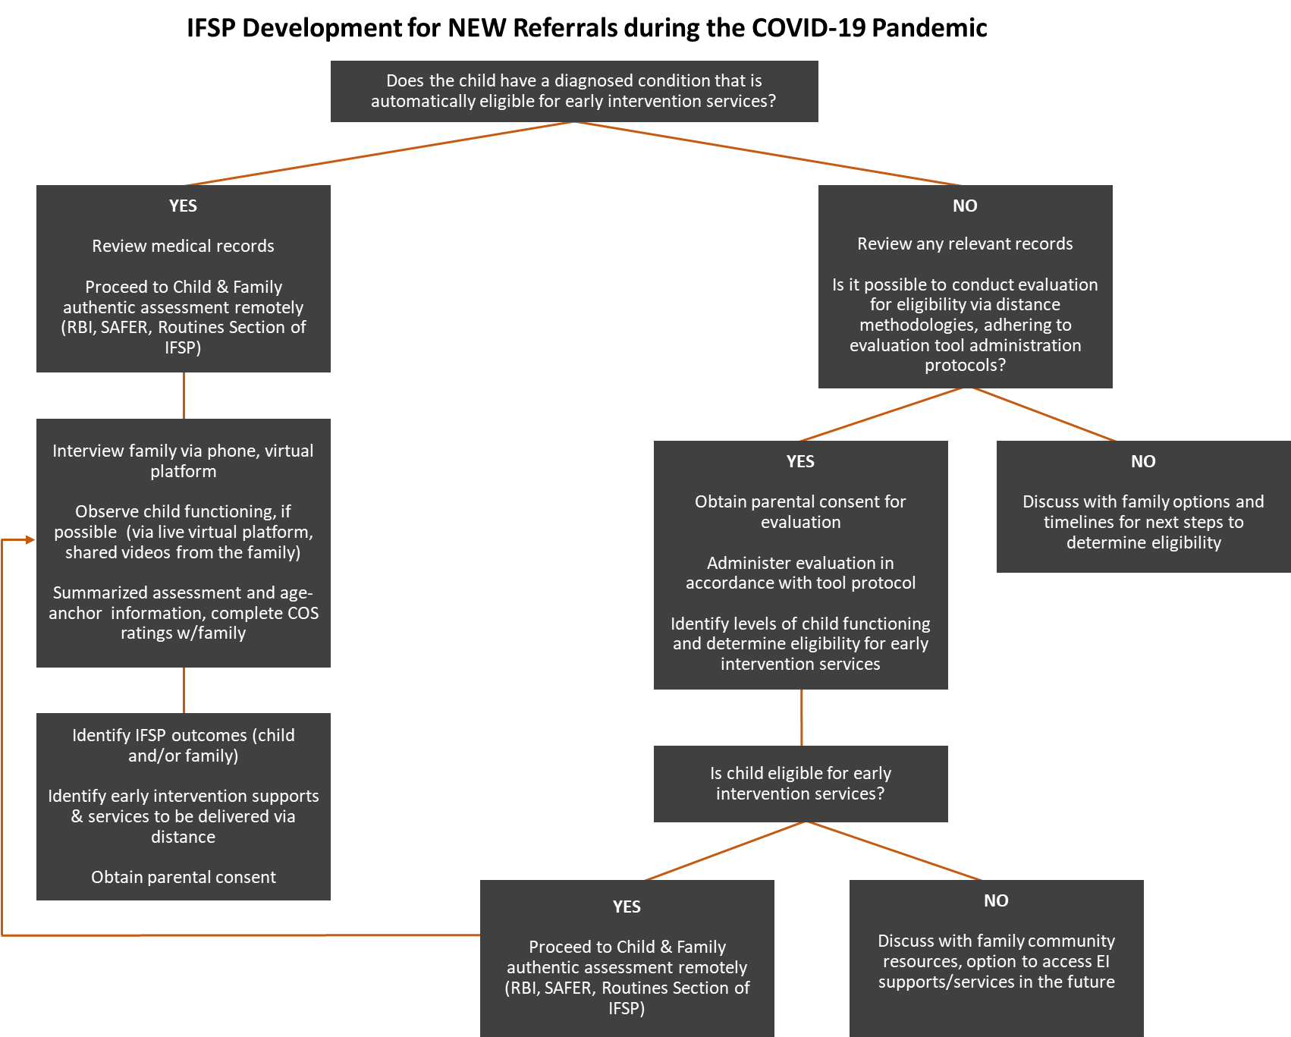

Figure 2. IFSP Development for NEW Referrals during the COVID-19 Pandemic (see Appendix B for a full-size readable document).

Implementation of Individualized Distance Service Delivery for Each Child and Family

A number of factors influence the implementation of individualized distance service delivery to young children and their families. It is critical that those involved in the discussion to modify early intervention service delivery effectively communicate with the family and other IFSP team members. These coordinated factors include but are not limited to:

- The schedule (time, frequency, and duration) for early intervention sessions. The family's main concerns and availability to engage with service providers is of the utmost importance. Consideration must be given for the caregiver's competing priorities related to family and work responsibilities. It is more important than ever to realize and communicate that all child learning takes place within the context of naturally occurring daily relationships, routines, and activities, in-between early intervention sessions.

- Embedding routines-based learning opportunities. Effectively embedding intervention strategies in everyday activities involve identifying what the family/team wants the child to learn, selecting the everyday activities that provide opportunities to learn things, and using teachable moments with the child to help him or her meaningfully participate in his or her daily life. The ability of family members to embed learning opportunities in a natural way throughout their day will have the most significant impact on child progress.

- Roles and responsibilities. Each IFSP team member must have a clear understanding of their roles and responsibilities during distance service delivery. An effective planning and communication system are essential for success. IFSP team members should frequently check in with families regarding any challenges the family is experienced and additional needs for support the family may have.

- Knowledge, resources, and technology for providers and families. The early intervention program must address training and coaching for all providers to successfully implement tele-intervention. For example, an effective provider must know what methods are to be used, and they must be skilled in the use of the technology and/or have a support system to seek assistance when needed. When technology differs across team members, including the family, barriers and challenges must be anticipated, planned for, and addressed.

In addition, the team must be sure that the family is familiar and skilled with using the selected platform, if applicable. Plans to ensure accessibility and accommodations for the family are necessary.

- Documentation of service delivery. The agreed-upon and operationalized distance service delivery must be documented. This can be achieved through the use of service delivery/encounter/contact logs that organize and document within the EIR the various elements of early intervention services during this time.

Consider the following questions to guide the implementation of individualized service delivery for each family.

- What are the service delivery options available for all families?
- How are the type, frequency, and duration of services considered in determining the service delivery schedule for families?
- What process exists to modify and adjust service delivery options?
- What training and supports do families need to use technology in order to engage in early intervention services to the greatest extent possible?

Resource availability plays a major role in determining how each program implements distance early intervention services. Please refer to Resources for Programs and Families (see page 9).

Frequently Asked Questions

Q: If the family agrees to a change in the frequency or duration of a service provided through individualized tele-intervention service delivery, is it necessary to modify the current IFSP? For example, the current IFSP requires 1 hour a week of special instruction, and through tele-intervention, the family agrees to two 30-minute sessions a week.
A: If service providers are focused on the needs of the child, the priorities of the family, and are making an intentional decision to provide services specified on the IFSP, then making shifts in frequency and duration based on the best interests of the child and family does not require an IFSP modification. Clear documentation of the parents' agreement to these individualized service delivery changes is necessary.

Q: If a new service is added to the IFSP, is it necessary to have an IFSP meeting?
A: When a new service is added to the IFSP, the team must hold an IFSP team meeting. Parent consent is necessary for the initiation of the new service.

Evaluation of Individualized Distance Service Delivery for Each Child and Family

A comprehensive plan, including distance service delivery, outlines how progress is being monitored for each infant, toddler, and preschooler with a developmental delay/disability. The unique needs of the child remain a consideration when monitoring and analyzing progress to make ongoing decisions and adjustments. In addition to monitoring child progress toward the IFSP outcomes, providers will continue to gather information relevant to the child's functional performance in the three early childhood outcome areas: development of positive social-emotional skills and relationships; acquisition of knowledge and skills to meaningfully participate in activities; and the use of appropriate behaviors to meet their needs.

The IFSP team may want to consider including a monitoring protocol to be included in all service delivery logs. This may include the development of methods for a family to collect data on their child's skills and behaviors within their daily routines. The adherence to a data collection and analysis schedule will play an important role when schools/programs resume normal operations so that teams are making individualized and data-informed decisions when it comes to discussions regarding child IFSP progress and additional services, the Child Outcomes Summary (COS) Process, as well as upcoming transitions. Teams may find that a program-wide documentation system needs modification to capture the needs of the individual child/family.

Frequently Asked Question

Q: Are COS ratings still being completed at entry, annually, and at exit prior to the age of 3, and exit after age 3?
A: When an initial, annual, or other IFSP review meeting is being held that requires a COS rating to be completed, providers in collaboration with families should do their best to complete the COS rating process with fidelity. Exit COS ratings must be completed, and in extenuating circumstances may be completed without family input if not available. In all circumstances the four core components must be utilized to the greatest extent possible to ensure fidelity to the process: 1) gather functional, routines-based information around each of the three early childhood outcomes; 2) consult age anchoring tools to age anchor the functional information; 3) use the COS Rating Prep Tool or colored highlighting to determine age expected, immediate foundational, or foundational for each functional skill; and 4) use the Decision Tree to come to a consensus about a COS rating in each of the three outcome areas.

Transitions from Early Intervention (Part C) IFSP Services to Extended IFSP Services or to Preschool Special Education (Part B 619) IEP Services During an Extended School/Agency Closure (COVID-19 Response)

Transitions from early intervention to preschool special education, require high levels of communication and coordination under normal circumstances. The need for local Part C and Part B collaboration to find solutions during school/program closures is intensified to ensure the smoothest transition possible for each child and family.

A Transition Planning Meeting (TPM) must occur within IDEA timelines; therefore, with parent agreement a meeting needs to held by alternative means. The purpose of TPM is to gather all current and relevant information about the child's development and functional knowledge and behaviors from the Part C program so that the team, with the Part B representative, can identify the next steps to ensure a seamless transition by the child's 3rd birthday. During school/program closure, it becomes increasingly more critical that the Part C program provide rich and robust information about the child's current functioning, including standard scores when available, so that eligibility for Part B services may be determined without additional assessments and evaluations. This will also inform the Part C Exit COS ratings and the Part B Entry COS ratings. A Part B program, in turn, needs to consider all of the information provided by Part C to make an eligibility determination without additional assessments when there is enough data to support the decision.

Determining eligibility for Part B prior to the child's 3rd birthday allows a family to be given a choice to continue receiving extended IFSP services or move to an IEP. In those instances, when eligibility has not been determined by age 3, a local system needs to consider possible options to ensure continuity of services/learning through Part C and Part B collaboration after age 3.

Resources for Programs and Families

Leadership and Infrastructure

- The ECTA Center serves as a hub for IDEA early childhood best practices and alternate models for providing early intervention and preschool special education and related services, including through distance services and supports. They will be collaborating with OSEP and other technical assistance partners to provide the most current and relevant information via the new and growing page on the Coronavirus: https://ectacenter.org/topics/disaster/coronavirus.asp

- Planning for the Use of Video Conferencing for Early Intervention Home Visits During the COVID-19 Pandemic (Larry Edelman)
https://ectacenter.org/~pdfs/topics/disaster/Planning_for_the_Use_of_Video_Conferencing_in_EI_during_COVID-19_Pandemic.pdf

- Planning for the Use of Video Conferencing for Preschool Special Education and Early Care and Education During the COVID-19 Pandemic (Larry Edelman)
https://ectacenter.org/~pdfs/topics/disaster/Planning_for_the_Use_of_Video_Conferencing_in_Preschool_during_COVID-19_Pandemic.pdf

- Council for Exceptional Children (CEC) Division for Early Childhood (DEC) Resources to Support EI/ECSE During the COVID-19 Outbreak
CEC has gathered resources into one place for special education professionals to apply good teaching practices remotely due to precautions surrounding the COVID-19:
https://www.dec-sped.org/ei-ecse-resources-covid-19

- DEC Early Intervention Community of Practice Telepractice Resources
Telepractice resources to assist with the temporary changes in how we provide supports for families in order to meet social distancing and "work from home" mandates during the COVID-19 outbreak:
http://deceisig.blogspot.com/2020/03/telepractice-resources.html

- ZERO TO THREE
Coronavirus Resources for Early Childhood Professionals to help the early childhood community be responsive to family needs during this challenging time:
https://www.zerotothree.org/resources/3291-coronavirus-resources-for-early-childhood-professionals

- National Center for Pyramid Model Innovations (NCPMI) Emergencies and National Disasters, Helping Children and Families Cope
Resources to support families in helping young children cope with the challenges that might occur during stressful emergency or disaster situations:
https://challengingbehavior.cbcs.usf.edu/emergency/index.html

- University of Maryland School of Social Work, The Institute for Innovation and Implementation Managing Now for a Better Tomorrow
A series of conversations and dissemination of helpful resources to support organizations' development of responses to COVID-19: https://theinstitute.umaryland.edu/" https://theinstitute.umaryland.edu/

- MA billing document Telehealth Common Questions & Answers, dated March 26, 2020.

Tele-intervention/Distance Service Delivery and Evidence-Based Practices

- COS Completion When Teams Can't Meet in Person - This document is intended to assist teams conducting COS rating determination meetings using telecommunication devices such as phones and/or computers with or without video to have discussions with team members in different locations through teleconferencing: https://ectacenter.org/eco/pages/cos-distance.asp

- Statements from Assessment Tool Publishers - This is padlet of evaluation tools that use parent interview/report and provide standard scores for eligibility determinations as well as statements from some publishers about the use of their tools remotely: https://padlet.com/eita/statments

- Telerehabilitation: An Adjunct Service Delivery Model for Early Intervention Services This article provides an overview of the research and potential for capacity building of this service delivery model. Jana Cason, DHS, OTR/L, International Journal of Telerehabilitation (Spring 2011): http://telerehab.pitt.edu/ojs/index.php/Telerehab/article/ view/6071/6301

- Tele-Intervention Video (Family, Infant and Preschool Program (FIPP) Dathan Rush
This brief video shows how you can use tele-intervention during this time of social distancing and includes an overview of system requirements, how to plan a visit, the three parts of a virtual visit, and what conducting a tele-intervention visit looks like in action. Additional resources include infographics about tele-intervention, tele-coaching, and tele-teaming:
https://www.assurethefuture.org/tele-intervention.html

- Tele-Intervention and the Routines-Based Model (Birth-5) (Robin McWilliam)
Home visits and early childhood education programs have been suspended during the COVID-19 Pandemic, but early interventionists can still provide supports to families. Robin McWilliam discusses how the principles of the Routines-Based Model match the demands of distance service delivery, the definition of tele-intervention, the research behind tele-practice, how to use tele-practice for the Routines-Based Interview, and how to use tele-intervention for home visits:
https://naturalenvironments.blogspot.com/2020/03/tele-intervention-and-routines-based.html

- Using the SS-OO-PP-RR: Guiding Home Visiting during the COVID-19 Pandemic
In this video, Juliann Woods, Jenny Seuntjens, and Larry Edelman discuss the use of the SS-OO-PP-RR framework for guiding home visits, whether in-person or delivered through video conferencing. They also discuss general considerations when delivering home visits during the COVID-19 Pandemic.
https://www.youtube.com/watch?v=RgQpTMSieTU&feature=emb_title

- Constructs of Effective Early Intervention Visits by Dr. Naomi Younggren – Webinar and Framework – COMING SOON on Maryland Learning Links!

- American Physical Therapy Association http://www.apta.org/Telehealth/
Includes a variety of resources on practice and billing, and a blog post on telehealth ethics best practice and the law (Aug 2019): http://www.apta.org/Blogs/PTTransforms/2019/8/28/Telehealth/

- American Occupational Therapy Association
Includes a position paper, webinar, and ethics advisory: https://www.aota.org/Practice/Manage/telehealth.aspx%22

- American Speech-Language-Hearing Association
Includes extensive information on key issues and resources; (including HIPAA and funding):
https://www.asha.org/About/Telepractice-Resources-During-COVID-19/

Families

- Encouraging Child Learning in Everyday Activities video
Intentionally including, or "embedding," learning opportunities in everyday activities at home or in your community is one way you can help your child learn new things. Embedding learning opportunities in everyday activities involves identifying what you want your child to learn, selecting the everyday activities that provide opportunities to learn things, and using brief "teaching" sessions with your child to help him or her become a more capable participant in his or her daily life: https://youtu.be/xlyXZumFXn8

- Practice Improvement Tools: Practice Guides for Families (ECTA Center)
Practice Guides for Families are a set of resources within the Practice Improvement Tools intended for practitioners to share with families. The Practice Guides are formatted for print as well as for viewing on mobile devices and are listed by the DEC
Recommended Practices topic areas: Assessment, Environment, Family, Instruction, Interaction, Teaming and Collaboration, and Transition. The Practice Guides for Families are also available in Spanish: https://ectacenter.org/decrp/type-pgfamily.asp

- ZERO TO THREE
Click on one of the three topical headings (i.e., early development and well-being, early learning, parenting) to find articles, tools, podcasts, and videos for engaging and supporting infants and toddlers, some of which are available in Spanish: https://www.zerotothree.org/

- NAEYC for Families
A good way to see all the options at this site is to click first on the top left box that says "Browse Articles By Topic." You'll find lots of information and ideas organized by topics that range from play to math and includes playful approaches to math! Select a topic, then enjoy the many options that are available: https://www.naeyc.org/our-work/fr-families

- 30 Days of Good Things for Young Children
The talented women at Good Things for Young Children have created a set of developmentally appropriate ideas to engage with children and made those resources available in English and Spanish. The activities support learning and development across all domains:
https://ec66a173-09bc-407a-ba3b-3357166208f4.filesusr.com/ugd/da44eb_8d45510f0bd64fa8bf7e8579b2dc332e.pdf (English)
https://ec66a173-09bc-407a-ba3b-3357166208f4.filesusr.com/ugd/da44eb_78917cfdfac547fca37aadab9d18e875.pdf (Spanish)

- Fun and Learning for Parents and Children: An Activities Handbook
Families may find this online booklet helpful. It contains fun activities for parents and children to do together at home, away from home, indoors, and outdoors:
https://eclkc.ohs.acf.hhs.gov/parenting/article/fun-learning-parents-children-activities-handbook

- Play by Age
This website is set up to assist readers in locating activities that will playfully support learning and development. The activities are developmentally appropriate for each age category and support multiple domains: https://www.learning4kids.net/

- Vroom
A set of tools and resources from the Bezos Family Foundation designed to inspire families to turn everyday moments into "brain building moments" by layering activities that are essential to healthy brain development onto existing routines. Vroom's website offers a variety of tools to download for free and many are available in English and Spanish: https://www.youtube.com/user/joinvroom and https://www.vroom.org/
Appendix A

Figure 1

Appendix B

Figure 2

For more information, call 410-767-0249
MARYLAND STATE DEPARTMENT OF EDUCATION
Division of Early Intervention and Special Education Services
200 West Baltimore Street
Baltimore, MD 21201

Karen B. Salmon, Ph.D.
State Superintendent of Schools

Brigadier General Warner I. Sumpter (Ret.)
President
State Board of Education

Carol A. Williamson, Ed.D.
Deputy State Superintendent for Teaching and Learning

Marcella E. Franczkowski, M.S.
Assistant State Superintendent
Division of Early Intervention and Special Education Services

Larry Hogan
Governor

TAB 20-01 also provides information on legal requirements under Part B of the IDEA, including free appropriate public education (FAPE) obligations, provision and documentation of services, and federal and state timelines.
The DEI/SES uses the terms distance service delivery and tele-intervention to mean the coaching and consultative methodologies implemented when there is physical distance between the early intervention provider and family. Tele-intervention and distance service delivery includes, but is not limited to, coaching, consultation, distance instruction (the use of instructional methodologies when there is physical distance), teletherapy (the provision of therapy through digital communications when there is physical distance), meetings held on digital platforms, online options for data tracking, and documentation.

