MARYLAND STATE DEPARTMENT OF EDUCATION
Division of Early Intervention and Special Education Services
IMPLEMENTATION BEST PRACTICES & CONSIDERATIONS
Marcella E. Franczkowski, M.S., Assistant State Superintendent

DATE ISSUED: February 2021, Revised August 2022

TIPs to Support Data Collection by Parents
During Virtual or Hybrid Learning

Data must continue to drive academic and behavioral programming decisions, and accurate data is critical to progress monitoring and the decision-making process. Data collection and analysis continue to be critical components in the development of educational programming; perhaps even more when virtual or hybrid learning are implemented. Given the impact of virtual or hybrid learning environments, collecting data on student behavior may result in incomplete information. It may not be possible to view students completely and see their body language, facial expressions, and movements. Therefore, it is important to rely on parents for this critical information whenever feasible, as parents and caregivers have access to what is not seen in the virtual learning environment. When students are learning from home, parents become even more critical to data collection, use of interventions, and monitoring progress. With intentional, proactive, individualized instruction, we can support parents to participate in and inform the data collection process.
New skills and behaviors are developed and improved through a systematic process. By using effective instructional practices, many parents will learn the skill of data collection. This process includes identifying the desired skill or behavior (i.e. data collection), understanding the individual’s baseline skillset, developing the plan to build or reinforce the skill, establishing the criteria for mastery, and evaluating progress. A recursive approach of data collection, review, and analysis to update and improve the effectiveness of the plan is best practice.
The following considerations can inform the process of gathering baseline information, the development and implementation of interventions, tracking progress, and identifying the skills needed for each of these components. Considerations and strategies are followed by a data decision tree for school staff.

To identify the baseline skill set of parents, consider the following questions:
- Does the parent understand why the data are being collected?
  - Is it to inform the development or an amendment of an Individualized Education Program (IEP)?
  - Is it for the development or update of a Functional Behavioral Assessment (FBA)?
  - Is it for the development or update of a Behavior Intervention Plan (BIP)?
  - Is it to track progress?
- Does the parent understand what behavior they are collecting data on?
  - Does the parent understand the operational definition of the behavior?
  - Does the parent understand what is included in the definition of the behavior (and what is not included)?
- Has the parent previously collected data in the home or in the community?
  - Has the parent received prior training or coaching?
  - If the parent has collected data, what types of data were collected?
- Does the parent have the time to commit to daily data collection?
  - If daily data collection, will data be collected throughout the day, or at specified time periods during the day?
  - What type(s) of data collection will be utilized?
  - How will the parent be trained, coached, and supported to collect the data?
- Does the parent have the time to commit to periodic data collection?
  - If periodic data collection, when will data be collected?
  - What type(s) of data collection will be utilized?
  - How will the parent be trained, coached, and supported to collect the data?
- How will the data be collected?
  - Can forms be shared with the parent?
  - Are electronic or hard copy forms best for the parent?
- How will the data collection be monitored?
  - How often will someone check in with the parent (daily, weekly, etc.) regarding the status of data collection?
  - Who will check in and provide coaching to the parent?
- How will the data collected be transferred to the school team?
  - Will school staff go to the home on a scheduled basis to collect data?
  - Will data be returned to the school electronically?

Skill Area | Strategies
Preparation strategies | - Operationally define the behaviors or goals that require data collection  - Ensure the behavior or goal definition is specific, observable, and measurable
Data collection equipment | - Include parent in decision-making regarding whether data collection will be with paper or electronic forms  - As appropriate, provide paper copies via mail or arrange for regular drop off of forms to parent home  - Talk with parents to ensure they have the tools necessary to perform data collection  Data Collection Method Resources:  PBIS World Data Tracking Behavior Tools - EdProDevelopment  Data Collection: Behavior PBS Tier-3 Monitoring  FBA Data Resources Special Education Data Collection
Type of data collection | - Consider whether a count of each instance of the behavior or the specific amount of time a behavior occurs is necessary (continuous data collection)  - Consider whether only a measure of a sample of the behavior is sufficient (discontinuous data collection)  - Utilize Data Decision Tree (see Figure 1) to make data collection determinations
Proactive strategies to teach and encourage parents to collect data | - Explain the rationale for data collection – used for programming decisions (both instructional and behavioral)  - Model how data is to be collected; have parents observe a school staff (such as a paraprofessional) collect data on the student  - Set up scenarios to role-play and rehearse data collection  - Offer parents videos of data collection techniques  - Have parents practice data collection to learn what to include and what not to include  - During practice sessions, provide coaching and feedback to parents so they can become comfortable with data collection forms and procedures
Response strategies to assist parents with data collection | - Have parent and staff (such as a paraprofessional) collect data for the same time-frame on a student and compare the data to see if it matches  - Review parent’s data collection on a student and offer feedback  - After training, offer check-in sessions to determine if parent and staff data collection continues to match for the same time-frame
Environmental modifications | - Ensure data collection takes place in a quiet area of the home, as possible, so parent is able to focus on observing the student  - Determine with parent where the best placement is for them to view the student for data collection

Figure 1: Data Decision Tree

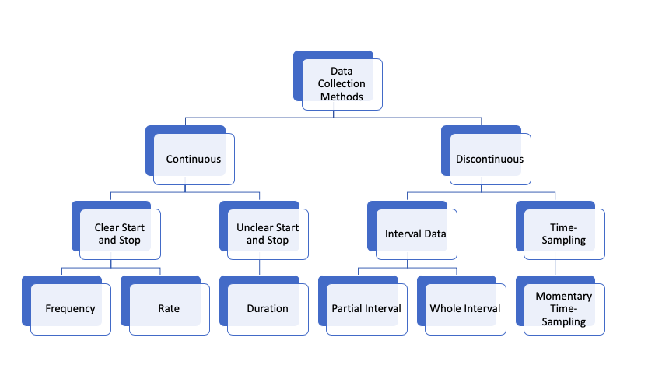

© 2022 Maryland State Department of Education.

Produced under the guidance of Marcella E. Franczkowski, Assistant State Superintendent, Division of Early Intervention and Special Education Services. Please include reference to the Maryland State Department of Education, Division of Early Intervention and Special Education Services on any replication of this information. To request permission for any use that is not “fair use” as that term is understood in copyright law, contact: Maryland State Department of Education, Division of Early Intervention and Special Education Services, 200 West Baltimore Street, Baltimore, Maryland 21201, 410-767-0249 voice.

Mohammed Choudhury, State Superintendent of Schools

Clarence C. Crawford, President, Maryland State Board of Education

Larry Hogan, Governor

Deanne M. Collins, Ed.D., Deputy State Superintendent for Teaching and Learning

Marcella E. Franczkowski, M.S., Assistant State Superintendent, Division of Early Intervention and Special Education Services

200 West Baltimore Street
Baltimore, Maryland 21201
MarylandPublicSchools.org
MarylandLearningLinks.org

