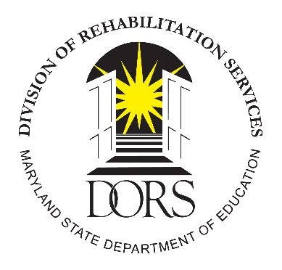
Maryland State Department of Education
Division of Rehabilitation Services
Peer Mentoring for Students with Disabilities
Site Quarterly Written Progress Report

Local Education Agency:

Date of Report:
Fiscal Year: Quarter: Period Covering: From to

DUNS #:
Grant #:

SECTION 1: CONTACT INFORMATION
Project Address:
Contact Person:
Contact Person Phone:
Contact Person Email:

SECTION 2: PEER MENTORING COORDINATOR ACTIVITIES THIS QUARTER
Activity (e.g., mentee/mentor recruitment, engagement with DORS, supervision of mentors, etc.)
1.
2.
3.
4.
5.
6.
7.
8.
9.
10.
11.
12.
Goal # of student mentees to participate in this project:
Total # of student mentees with prior approval through DORS to participate:
Goal # of student mentors to participate in this project:
Total # of student mentors with an open DORS Pre-ETS or VR case:

SECTION 3: GROUP ACTIVITIES THIS QUARTER
Activities facilitated or provided by the Peer Mentoring Coordinator (e.g., group activities focusing on topics such as general career exploration, vocational rehabilitation services, post-secondary exploration, understanding accommodations and how to request them, self-advocacy in ones Individualized Education Program, etc.)
1.
2.
3.
4.
5.
6.

SECTION 4: GENERAL PROJECT NARRATIVE THIS QUARTER
(Narrative to include comments regarding this quarter’s activities, difficulties encountered, etc.)

Note: Individual student progress reports for all student mentees are required to be submitted on a monthly basis.

Peer-Mentoring Coordinator’s Signature: Date:

