American Rescue Plan Elementary and Secondary Schools Emergency Relief Afterschool Program

PR
GRANT RENEWAL APPLICATION
Fiscal Year 2023 (Year Two)
Maryland State Department of Education
200 West Baltimore Street
Baltimore, Maryland 21201

Deadline
January 13, 2023
No later than 5:00 pm EST

Mohammed Choudhury
State Superintendent of Schools
Secretary-Treasurer, Maryland State Board of Education
Dr. Sylvia Lawson
Deputy Superintendent for Organizational Effectiveness
Mary L. Gable
Assistant State Superintendent, Division of Student Support, Academic Enrichment, and Educational Policy
Larry Hogan
Governor

MARYLAND STATE DEPARTMENT OF EDUCATION

Clarence C. Crawford
President, Maryland State Board of Education
Susan J. Getty, Ed.D. (Vice President)
Shawn D. Bartley, Esq.
Gail Bates
Chuen-Chin Bianca Chang
Charles R. Dashiell, Jr., Esq.
Vermelle Greene, Ph.D.
Jean C. Halle
Dr. Joan Mele-McCarthy
Rachel L. McCusker
Lori Morrow
Brigadier General Warner I. Sumpter (Ret.)
Holly C. Wilcox, Ph.D.
Merin Thomas (Student Member)
MARYLAND STATE BOARD OF EDUCATION

Table of Contents
Program Description 4
Name of Grant Program 4
Authorization 4
Purpose 4
Dissemination and Deadline 5
Grant Period 5
Funding Amount 5
Grant Awards 5
Program Contact 6
Eligible Applicants 6
Use of Funds 6
Examples of Allowable Expenses 6
Examples of Unallowable Expenses 7
Program Requirements 8
Required Minimum Hours of Programming 8
Performance Goals and Indicators 8
Alignment with Maryland College and Career-Ready Standards 8
Alignment With The National Afterschool Alliance (NAA) Association Core Knowledge And Competencies 8
Implementation and Governance Plan 12
Leadership Team Description 12
Steering Committee Description 12
Management Plan 12
Partners 15
Evidence of Impact 17
Evaluation and Dissemination 17
Programmatic Monitoring 19
Critical Elements Monitoring 19
Program Observation 19
Leveraging Private and Existing Funding Sources 19
Sustainability 19
Matching Contributions 19
Branding 20
Budget and Adequacy of Resources 20
Budget Worksheet and Narrative Template 20
Conflict of Interest 22
Audit Requirements 22
The General Education Provisions Act (GEPA), Section 427 22
Customer Service Support Session 23
Awarding of Funds 23
Denial of Grant Application 23
Reasons for Denial 23
Non-Discrimination Statement 23
Attachment 1: ARP ESSER Performance Report and Renewal Application Form 24

Program Description

Name of Grant Program
The Maryland State Department of Education (MSDE) administers the American Rescue Plan Elementary and Secondary School Emergency Relief Afterschool Program (ARP ESSER ASP) to assist local education agencies (LEAs), public charter schools, and nonprofit [501(c)(3)] organizations in the State to establish partnerships designed to support the creation of after school learning centers to provide academic enrichment opportunities during after school hours for children, particularly students who attend high-poverty and low-performing schools. The programs will assist students to meet or exceed state and local student standards in core academic subjects such as reading and math and offer students a broad array of enrichment activities that can complement their regular academic programs.
Community-based agencies and LEAs develop partnerships to provide academic and enrichment services to ensure students’ academic, social, emotional, and mental health needs are being addressed. Programs are developed and implemented in active collaboration with the school that the student attends.
The ARP ESSER ASP grant recipients are requested to complete the Grant Renewal Application to provide programmatic and fiscal outcome data for the 2021-2022 grant award period and a 2022-2023 grants management plan for review in consideration for year two funding. The applicant is requested to submit the data electronically through accessing the ARP ESSER Performance Report and Grant Renewal Application Form. The details of the e-application are included in Attachment 1. Upon submission, the MSDE will review the provided Grant Renewal Application and the year one performance data which includes, but is not limited to, the: (1) Start-up report, (2) Critical Elements Monitoring Stage I, II and III, (3) Timely reimbursement invoice submissions, and (4) Total number of amendments. Upon review, applicants approved for year two funding will receive a risk assessment level of 1-5 that will be reflected on the Year II Notification of Grant Award (NOGA).

authorization
Under ESSER, established in the Coronavirus Aid, Relief, and Economic Security (CARES) Act, Pub. L. No. 116-136 (March 27, 2020), and further funded under the Coronavirus Response and Relief Supplemental Appropriations (CRRSA) Act, 2021, Pub. L. No. 116-260 (December 27, 2020) and the American Rescue Plan (ARP) Act of 2021, Pub. L. No. 117-2 (March 11, 2021), the U.S. Department of Education (Department) awarded grants to State educational agencies (SEAs) for the purpose of providing LEAs that receive funds under Title I Part A of the Elementary and Secondary Education Act (ESEA) of 1965, including charter schools that are LEAs, with emergency relief funds to address the impact the COVID-19 pandemic has had, and continues to have, on elementary and secondary schools across the nation.

PURPOSE
The purpose of the ARP ESSER ASP grant awards is to provide funding for the implementation of evidence-based, comprehensive after school programs, and ensure such programs respond to students’ academic, social, and emotional needs and address the disproportionate impact of the coronavirus on the student populations.

DISSEMINATION AND DEADLINE
The renewal application was released on December 5, 2022. The deadline for the application submission is Monday, December 12, 2022.

GRANT PERIOD
Length of Grants: Three years
- Period of Availability for Year 2: September 1, 2022, through August 31, 2023.

The MSDE will award grants for a total of 36 months which is subject to funding. Applicants are required to submit a three-year budget outlining expenses for each year. Following the initial year, funding for subsequent years will be contingent upon:
- availability of funding from the specific funding authority;
- satisfactory performance by the grantee as evaluated by the MSDE; and
- compliance with all grant requirements and meeting all conditions set forth within the ARP ESSER ASP proposal.

FUNDING AMOUNT
Total Funds Available: $19.5 million

GRANT AWARDS
The MSDE will use the standards in the Uniform Guidance to impose specific or “high risk” conditions on applicants selected for funding, including but not limited to: applicant or recipient history or failure to comply with the general or specific terms and conditions of the grant, failure to meet expected performance goals and may impose additional specific award conditions as needed (See Uniform Guidance section 200.207). The MSDE will assess the risks facing the applicant entity as it seeks to achieve its objectives. This assessment will provide the basis for determining awards to high-risk applicants.
Grant amounts each year will be funded at one hundred percent of the original award contingent on the availability of funding and satisfactory performance. Programs selected for funding will be level funded the same amount for each of the four years of programming unless a lesser amount is specified for subsequent years. In those cases, the lesser amount will be awarded. In addition, awards may be reduced based on the grantee’s inability to meet the goals and performance measures set forth in this grant. This includes participation numbers consistently lower than projected in the bidder’s application. Awards may also be reduced based on fiscal or programmatic concerns or findings during the grant period. Any award reductions will be discussed with the applicant in advance of the reduction.
The MSDE reserves the right to continue or discontinue the program(s) for the reasons defined in 2 CFR § 200.208 and for non-compliance of the requirements listed below:
- Demonstrate adequate progress toward achieving all measurable objectives;
- Meet or exceed 85 percent of the proposed level of students served, as indicated on the original ARP ESSER ASP application, or the Grant Renewal Application for the most recent year of operation;
- Attend required out-of-school (OST) national and regional conferences, MSDE grantee meetings and trainings;
- Submit required documentation in a timely manner during the project year as requested and/or required by MSDE, such as:
  - Monitoring components (Start-Up, Interim, Grant Renewal Application, End of Year Reports, and Critical Elements Monitoring)
  - Corrective action(s)
  - Monthly Reimbursement Expenditure Report submission
  - Detailed local narrative evaluation report reflecting the growth and progress of the program;
- Participate fully in statewide evaluation activities; and
- Comply with all applicable state statutory and regulatory requirements.
The MSDE ARP ESSER ASP program allows a subgrantee to carryover ARP ESSER ASP funds that were not used in the current grant budget year for approved activities that would most benefit from additional funding. The amount of FY22 carryover funds is determined based on the unspent funds from the Year One budget. Grant funds must be expended in the grant year they were awarded.

PROGRAM CONTACT
Reginald Burke
Director, Youth Development Branch
Maryland State Department of Education
reginald.burke@maryland.gov
410-767-0313 (office)

Eligible Applicants
Schools eligible for services provided by this grant are:
- Comprehensive Support and Improvement Schools (lowest 5 percent of the Title I schools; high schools with graduation rates less than 67 percent; and/or
- Title I Schools that serve a high percentage (at least 40 percent) of students from low-income families; and/or
- Other schools are determined by the LEA to need intervention and support.

Use of Funds

Examples of allowable expenses (not an Exhaustive list)
- Intervention, strategies, and curriculum purchases (must meet ESSA evidence criteria).
- Salaries and fringe benefits for ARP ESSER ASP staff;
- Professional development and ARP ESSER ASP trainings;
- Consultants, subcontractors, and evaluators providing allowable services/activities;
- Implement policies in line with the guidance from the Center for Disease Control for the reopening and operation of school facilities;
- Supplies to maintain the public health protocols to ensure the health and safety of students to include personal protection equipment, cleaning and sanitizing materials, portable air purifiers, and emergency supplies;
- Classroom materials and supplies for ARP ESSER ASP classes;
- Food services for LEAs, if not provided by any other funding sources;
- Remedial education activities and academic enrichment learning programs, including providing additional assistance to students to allow the students to improve their academic achievement;
- Core academic subject educational activities;
- Arts and music education activities;
- Address and promote family engagement and dual capacity building for staff and families of English learners;
- Entrepreneurial education, college, and career readiness programs;
- Tutoring services (including those provided by senior citizen volunteers) and mentoring programs;
- Programs that provide out-of-school activities for limited English proficient students that emphasize language skills and academic achievement;
- Recreational activities;
- Telecommunications and technology education programs;
- Implement social emotional strategies and supports for students;
- Drug and violence prevention programs; and
- Counseling programs.

Examples of UNallowable expenses (not an Exhaustive list)
- Preparation of the proposal: Costs to develop, prepare, and/or write the ARP ESSER ASP proposal cannot be charged to the grant directly or indirectly by either the agency or contractor;
- Pre-award costs: Pre-award costs may not be charged against the grant;
- Funding for activities conducted and costs incurred before the start date of the grant;
- For non LEAs, food is an unallowable expense;
- Entertainment is not allowed. A field trip without the approved academic support (will be considered entertainment);
- End-of-year celebrations or food associated with parties or socials;
- Game systems and game cartridges;
- Unapproved out-of-state or overnight field trips, including retreats and lock-ins;
- Incentives (e.g., plaques, trophies, stickers, t-shirt, give-a-ways);
- Advertisements, promotional, or marketing items;
- Decorative items;
- Purchase of facilities, vehicles (e.g., buses, vans, or cars), or land acquisition;
- Capital improvements, permanent renovations;
- Direct charges for items or services that the indirect costs rate covers;
- Dues to organizations, federations, or societies for personal benefit; and
- Any costs not allowable for federal programs per Uniform Guidance 2 CFR§ 200.400.

Program Requirements

Required minimum Hours of Programming
The MSDE shall select applications that demonstrate the ability to successfully implement afterschool programs that extend or expand the academic enrichment programming day by a minimum of eight hours each full week that school is in session.

Performance Goals and Indicators
The MSDE identifies performance goals to evaluate the effectiveness of the ARP ESSER ASP grant programs. The applicant is responsible for identifying the Performance Indicators, Maryland College and Career-Ready Standards, National Afterschool Association Alliance Core Knowledge and Competencies for Afterschool and Youth Development for Professionals, Activities, Data Source(s) and Evaluation Methods to achieve the specified goal.
Annual renewal requires applicant reflection and analysis of performance outcomes (see Attachment 1). Evaluative findings and programmatic practice drive informative and systematic changes that enhance implementation. Applicants are to apply the programmatic and evaluative findings to their succession planning for year two implementation and therefore, conduct a review and revision of the original exhibits included in the RFP. The exhibits required as a part of the Grant Renewal include: (1) Performance Goals and Indicators, (2) Management Plan, (3) Partner Plan, and (4) Evaluation Plan. Final documents are to be submitted as a part of the Grant Renewal Application and uploaded into the 2022-2023 Critical Elements Monitoring folder by December 19, 2022.

Alignment with THE Maryland College and Career-Ready STandards
The applicant must ensure that the proposed after school program has an educational component that is age appropriate and aligns with the Maryland College and Career-Ready Standards. The Maryland College and Career-Ready Standards cover English Language Arts, Mathematics and Literacy in History/Social Studies, Science, and Technical Subjects. These standards define what students should know and be able to do at each grade level and align with state standards and state assessments. The applicant must identify the applicable grade level Maryland College and Career-Ready Standards.

Alignment with The NATIONAL Afterschool Alliance (NAA) Association Core Knowledge and competencies
The applicant must integrate the National Afterschool Association Alliance Core Knowledge and Competencies for Afterschool and Youth Development for Professionals. Core competencies describe the knowledge, skills and dispositions needed by professionals to provide high-quality afterschool and youth development programming, as well as support the learning and development of youth. Competencies are concrete, observable and achievable; they establish standards of practice to strengthen the profession as stated by National Afterschool Association.
The core knowledge and competencies are grouped into ten content areas listed below. The content areas are categories of knowledge that are widely used in the field and based on research.

- Child/Youth Growth and Development;
- Learning Environments and Curriculum;
- Child/Youth Observation and Assessment;
- Interactions With Children and Youth;
- Youth Engagement;
- Cultural Competency and Responsiveness;
- Family, School, and Community Relationships;
- Safety and Wellness;
- Program Planning and Development; and
- Professional Development and Leadership

Performance Goals and Indicators
Page 1 of 2:
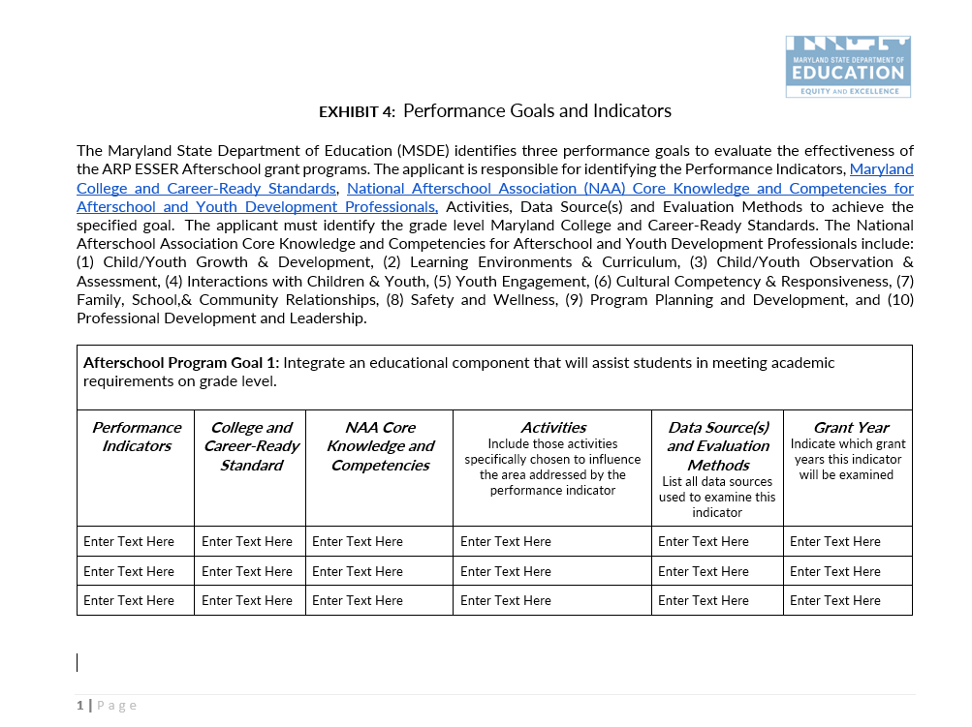

Performance Goals and Indicators
Page 2 of 2:
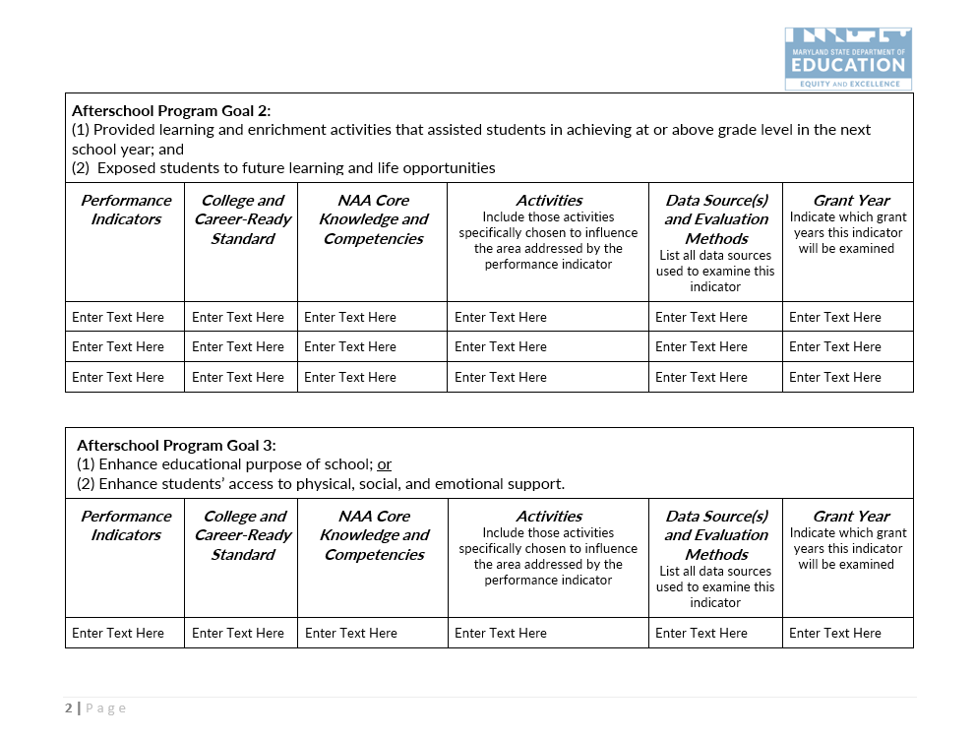

Implementation and Governance Plan

Leadership Team Description
The applicant must identify the project’s leaders, including the roles and positions, as well as, expected qualifications, and specify how much of the project director’s time will be devoted to this project, as per Uniform Guidance 2CFR 200.430. In support of salaries and wages, documentary support will be required where employees work on, a Federal award and a non-Federal award.
The applicant must describe who will be included on the leadership team (e.g., project director, site coordinators, board members, students, parents, etc.), how the leadership team will ensure successful implementation of the project, how often they will meet, and actions to oversee positions responsible for grant implementation.
The applicant must identify the positions that will be responsible for grant implementation (ex: Grant Manager, Bookkeeper, Academic Instruction Teachers, Enrichment Teacher, Parent Liaison, Evaluator, etc.).

Steering Committee description
The project must have a steering committee to govern the project consisting of major stakeholders and grant project directors. Duties of the steering committee include establishing major program policies, reviewing quarterly milestones and annual evaluation reports, and making recommendations for programmatic change. Steering committee members should represent the major stakeholders in the project (e.g., project partners, parents, students, principals, Board of Education members). Project directors should act as advisors to the committee. The duties, members, and meeting dates of the committee should be identified in this section of the project proposal and in the Management Plan.

Management PLan
The Management Plan section describes how and by whom the program will be managed to ensure project success.
This section must:
- Describe how, when, and by whom the program’s implementation will be monitored, including starting the project on time.
- Describe the mechanisms by which the project will clearly define and hold partners accountable to specific roles, responsibilities, contributions, and deliverables, e.g., contracts or Memoranda of Understanding.

The Management Plan Worksheet details the major management actions and the timeframe and specific persons responsible for each action. The worksheet supports the proposed Plan of Operation, but includes only management actions, not direct service activities. Examples of management actions are hiring of staff, ordering equipment, and developing curricula. Meetings with the evaluator and holding steering committee meetings must occur within 30 days of the Notice of Grant Award.
On the Management Plan Worksheet, in chronological order, the grantee needs to list all major management Specific, Measurable, Attainable, Relevant, and Time-based (SMART) actions necessary to implement the project during the second year of funding. The grantee needs to assign a responsible party, measurable outcome, and an approximate date for each action. If the action is ongoing, indicate the range of dates over which it will be implemented. The MSDE reporting requirements should also be included in the management plan.

Management Plan
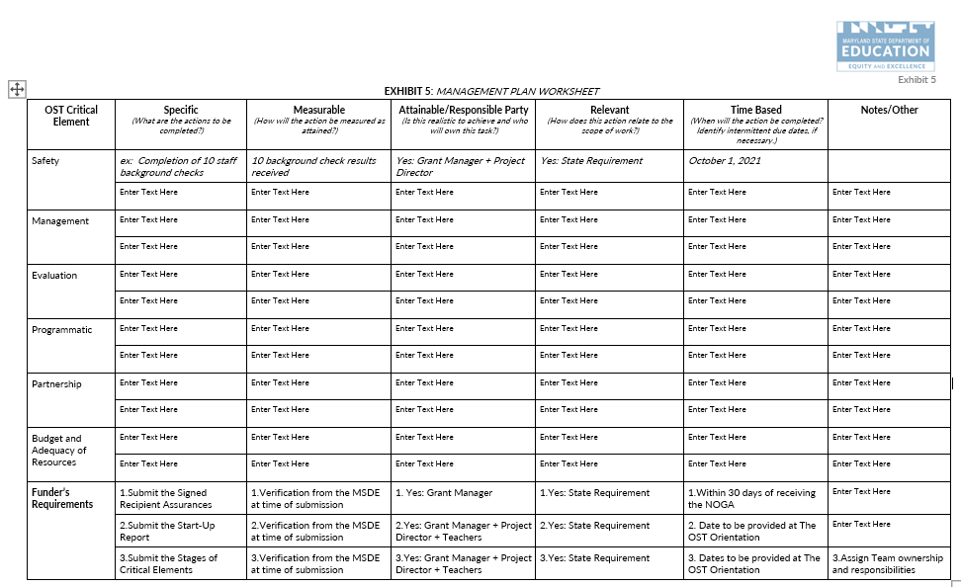

Partners
A partner is any organization other than the grantee that will actively contribute to the project. This includes the LEA(s) being served, local parks and recreation departments, recreation councils, public libraries, institutions of higher education, private sector business, and other nonprofit [501(c)(3)] organizations and foundations. Partners include subcontractors, organizations that are under contract with the grantee to provide grant-funded activities or services. If renewed, all applicants must ensure the MSDE OST Team has a record of the current contract/Memorandum of Understanding (MOU) in the applicant Budget Documents folder. New or revised contracts are to be submitted with the FY23 budget documents for MSDE review and approval. Contracts require review and approval before funds will be released for reimbursement. Funds paid to partners by the applicant without an approved contract are subject to non-reimbursement.
The Partners Plan Worksheet shows the project’s partners, the respective roles in the project, the benefits each expects to receive, and the specific contributions each partner will make to the project in the form of financial support, equipment, personnel, or other resources. The grantee should include which objectives their services will help to achieve, as well as evaluation dates to reflect on progressing and/or achieved outcomes.

Partners Plan

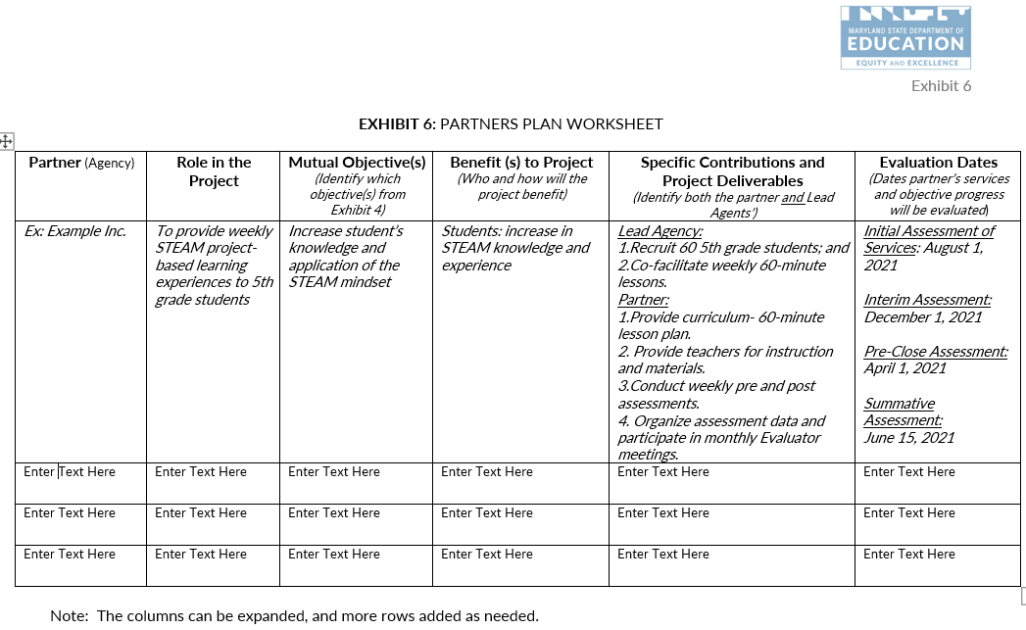

Evidence of Impact
Describe how the proposed plan and strategies being implemented are evidence-based and will lead to the desired impact. Include a description of the organization’s experience in terms of effective practices (research-based strategies) leading to the desired outcomes.

Evaluation and Dissemination
Program evaluation is a critical and essential process of program implementation. Program evaluation involves the systematic collection and analysis of information related to the design, implementation, and outcomes of a program for the purpose of assessing and subsequently modifying program activities to ensure program efficacy and effectiveness. The Evaluation Plan outlines the process by which the program will be evaluated. The evaluation must include a plan for a professional, independent evaluation of the program.
The evaluation plan must also address the following:
- Specify the questions the evaluation will seek to answer, based on the project’s objectives, and plan of operation. These questions must enable project leaders to assess progress toward objectives and milestones and enable project managers to determine which strategies and activities have been successful, and those that need to be revised.
- Describe the proposed data and measurement instruments that will be used.
- Explain how data will be collected, including who is responsible, and provide a timeline.
- Describe how the integrity and accuracy of data will be ensured.
- Specify the third-party individual or group who will conduct the external evaluation or provide a detailed job description and the selection process by which a qualified evaluator will be identified.
- Describe how and when evaluation findings will be used to make improvements in the project.
- Describe how the evaluation findings will be disseminated to the major stakeholders and all individuals with an interest in the project. Explain how dissemination formats will be tailored to meet the needs of diverse stakeholders.

Through implementation of the Evaluation Plan, the applicant will provide a summative Evaluation Report to the MSDE following the project year implementation. An evaluation report will integrate the following components:

- Evaluation Framework/Purpose;
- Methodology;
- Evaluation Findings;
- Summary;
- Recommendations and Limitations.

Applicants operating multiple sites are to submit one evaluation report with a summary, recommendations, and limitations for all operating sites and individual data reported for each operating site, as outlined below:

- Evaluation Framework/Purpose;
- Methodology; and
- Evaluation Findings.

Evaluation Plan

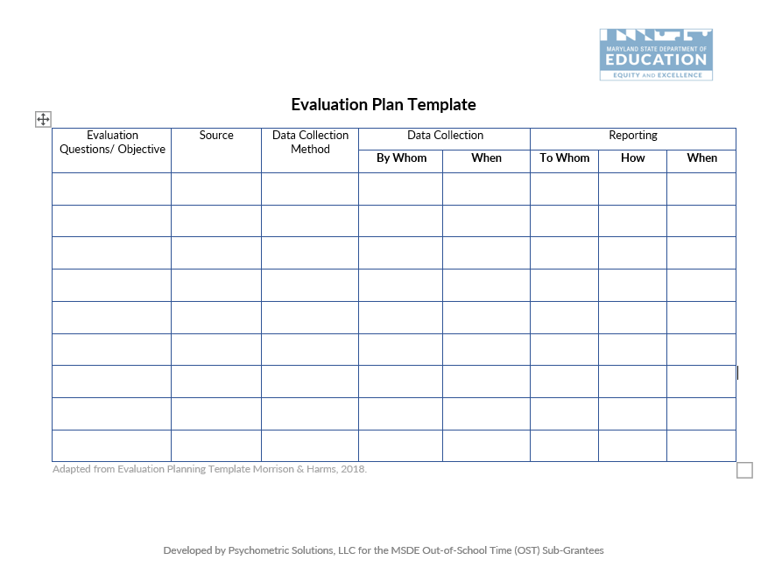

Programmatic Monitoring

Critical Elements monitoring
The applicant is required to comply with requirements of the grant program (including completion of data) on an annual basis through documentation and evidence review. The OST Critical Elements monitoring is comprised of stage evidence submission in the following areas: (1) Programmatic Compliance with Federal, State and Local Health and Safety, (2) Programmatic, (3) Evaluation, (4) Management, (5) Sustainability, and (6) Budget and Adequacy of Resources. The MSDE conducts a review of the evidence and identifies corrective actions for applicant completion, as well as priorities for technical assistance through program observation. The grantee's ability to comply will affect the monitoring risk assessment indicator, as well as advise the MSDE technical assistance.

PRogram Observation
The applicant must implement quality academic enrichment as aligned with the approved grant program. The MSDE conducts onsite observations of the following program components: (1) academically aligned objectives; (2) student engagement; (3) adherence to the grant requirements; (4) leveraging of partnerships; and (5) data informed decisions. The goal of program observation is to provide positive, constructive, and immediate feedback to grantees regarding the implementation of the OST grant funded program as aligned with the original proposal or as amended.
At the conclusion of the onsite visit, the MSDE Extended Learning Specialist discusses the observation results with the grantee, provides additional guidance, as well as addresses corrective actions. The grantee will have an opportunity to provide any missing documentation within a specified timeframe.

Leveraging Private and Existing Funding Sources
The MSDE encourages applicants to illustrate the ability to leverage federal, state, private and existing funding sources. If applicable, applicants should include on the Budget Worksheet and Narrative how private and existing funding sources will be combined or coordinated with the proposed grant funding to illustrate the effective use of resources.

Sustainability
The MSDE will fund all three years of the project at 100 percent, subject to continued grant compliance and federal funding. The MSDE encourages applicants to evaluate plans to expand partnerships and develop new public/private partnerships. It is expected that all programs funded will acquire other funds to assist in sustaining the program in Year 3 and beyond.

MATCHING CONTRIBUTIONS (If applicable)
Proposed budgets may include cash and third-party in-kind contributions (including but not limited to material, personnel, and other types of contributions) each year. Third party in-kind contributions cannot be derived by the state under another award, except where authorized by a statute to be used for cost sharing or matching. Matching contributions are not required for ARP ESSER ASP funding.

Branding
All ARP ESSER ASP grant recipients are required to identify MSDE as the funding source for ARP ESSER ASP funds in all written advertisements. If a grantee receives partial funding from additional sources, they may note that funding for the ARP ESSER program is received in part from MSDE.

Budget and Adequacy of Resources
All ARP ESSER ASP awards are reimbursement grants, whereby each program incurs costs and then invoices MSDE for those charges. Grantees must have sufficient cash flow to operate the ARP ESSER ASP program continuously while awaiting reimbursement receipt, which normally takes approximately six to eight weeks. Interest expense or other debt services costs cannot be charged to the ARP ESSER ASP grant. Check cashing fees cannot be charged to the grant. If unallowable costs are reimbursed during the grant period, corrective actions will be provided and require the funds to be repaid to the MSDE.
The grant budget consists of two components:
- The Budget Worksheet and Narrative; and
- The approved MSDE Grant Budget Forms (C-1-25).

The budget objects are: (1) Salaries & Wages; (2) Contracted Services; (3) Supplies & Materials; (4) Other Charges; (5) Equipment; and (6) Transfers. The budget object totals in the Budget Worksheet and Narrative must align with the totals identified on the MSDE Grant Form C-1-25.

BUDGET WORKSHEET AND NARRATIVE TEMPLATE
The budget narrative is a part of the Budget Worksheet and Narrative Template (Exhibit 8). The Budget Narrative must:
- Describe a clear relationship between the activities described in the application and the proposed allocation of grant funds;
- Address the necessity and rationale of proposed costs;
- The budget section must demonstrate that there are sufficient resources to successfully implement the proposed program as described in the project narrative, including, but not limited to, instructional staff, curricular materials, evaluation, professional development, background checks, and transportation, if necessary; and
- Applicants must list all budgetary costs based upon the narrative components and program design and ensure the budget includes a line-item description for every allowable cost necessary to carry out the goals and objectives of the proposed program.
The budget must:
- Detail the year of the project in an itemized budget;
- Itemize general expenses into specific line items. For example, “Meeting Expenses” can be itemized to include, “room rental” and “photocopying;”
- Clearly identify the requested funds and in-kind contributions; and
- Identify the source of each in-kind contribution, if applicable.
Identify reasonable and allowable expenses aligned with the United States Department of Education (USDE) Uniform Grant Guidance, 2 C.F.R. Part 200, (2 CFR § 200). The Electronic Code of Federal Regulations (E-CFR) is accessible at: https://www.ecfr.gov/cgi-bin/text-idx?tpl=/ecfrbrowse/Title02/2cfr200_main_02.tpl. Utilize The Maryland Financial Reporting Manual as an additional resource when categorizing allowable expenses. Utilize the Bureau of Labor and Statistics National Occupational Employment and Wage Estimates database to identify reasonable and allowable wages.
Adhere to the following guidelines when proposing expenses in the specified budget objects.
- Salaries and Wages: Expenditures incurred for personnel on the payroll.
  - Specify and detail how the expense was calculated for each line item. The calculation column must include hourly rate of pay provided based on the reasonable and allowable rates of pay aligned with the U.S. Bureau of Labor and Statistics (BLS), number of hours billed to the project, percentage of time billed to the project;
  - Program staff identified under Salaries/Wages and Contractual Services must remain in that budget object for the remainder of the grant year;
  - The budget must include a position or contracted services expense for a finance agent/bookkeeper; and
  - Program staff identified under Salaries/Wages must include paycheck withholding as supporting documentation when submitting reimbursement invoices.
- Contracted Services: Expenditures for services performed by persons who are not on the payroll.
  - Specify and detail how the expense was calculated for each line item. The calculation column must include hourly rate of pay based on the reasonable and allowable rates of pay aligned with the U.S. Bureau of Labor and Statistics, administrative fees, and number of hours billed to the project. Please provide the following in the calculation column and embed the hyperlink to the BLS reference;
  - Vendors that provide direct services to students must submit a proposed Memorandum of Understanding (MOU) outlining the deliverables and breakdown of expenses to include hourly rates and administrative costs for all providers. The MSDE acknowledges that MOUs may not be finalized at the time of the application; however, a proposed agreement is required that outlines the details of partnership; and
  - The external evaluator cost cannot exceed seven percent of the Total Requested.
- Supplies and Materials: Refer to 2 C.F.R. Part 200, The Maryland Financial Reporting Manual, Appendix D for a definition. The total object cannot exceed eight percent of the Total Requested.
  - Specify and detail how the expense was calculated for each line item. The calculation column must include quantity and cost per item.
- Equipment: Refer to 2 C.F.R. Part 200, and The Maryland Financial Reporting Manual, Appendix D for a definition. The total object cannot exceed three percent of the Total Requested.
- Other Charges: May include expenses such as travel, conferences, fringe, etc. (not an inclusive list). The total object cannot exceed 36 percent of the Total Requested.
  - Professional Development:
    - Include funds to cover travel and lodging expenses for at least two key personnel to attend one national and two regional training activities during each year of the project (actual attendance will be contingent on MSDE approval).
    - Include funds for the project director to attend three state grantee networking meetings; and
    - Include funds for the project director to attend one two-day state grantee retreat.
- Transfers: The total object cannot exceed 13 percent of the Total Requested.
- Indirect Cost Rate:
  - Indirect Costs cannot exceed 10 percent of the Total Direct Cost for Non-LEAs; and
  - Refer to Section 5.0.5 Indirect Costs for calculation guidance.

Both requested and in-kind funds must be reasonable with current market prices. Grant funds cannot be used to purchase food, facilities, vehicles, or support new construction.

Conflict of Interest
All potential conflicts of interests should be avoided. According to the general procurement standards, the non-federal entity must maintain written standards of conduct covering conflicts of interest and governing the actions of its employees engaged in the selection, award, and administration of contracts. No employee, officer, or agent may participate in the selection, award, or administration of a contract supported by a federal award if he or she has a real or apparent conflict of interest. Such a conflict of interest would arise when the employee, officer, or agent, any member of his or her immediate family, his or her partner, or an organization which employs or is about to employ any of the parties indicated herein, or has a financial or other interest in or a tangible personal benefit from a firm considered for a contract. The officers, employees, and agents of the non-federal entity may neither solicit nor accept gratuities, favors, or anything of monetary value from contractors or parties to subcontracts. The standards of conduct must provide for disciplinary actions to be applied for violations of such standards by officers, employees, or agents of the non-federal entity (EDGAR 2 CFR §200.318).
Within the ARP ESSER ASP program, conflicts of interest could include:
- Employing immediate family members as contract labor for services;
- Having a program employee serve as a vendor; and
- Purchasing supplies from a company in which a program employee has a financial interest.

Audit Requirements
Any subrecipient that expends $750,000 or more of federal awards in a fiscal year must have a single or program-specific audit conducted for that year in accordance with the provisions set forth in 2 CFR Part 200, Subpart F – Audit Requirements. Subrecipients must submit a copy of their single audit report and financial statement to the MSDE. These reports must be submitted within nine months after the end of the fiscal year, or 30 days after the auditor has signed the report, whichever comes first.
If a sub recipient did not expend $750,000 or more in federal awards, the sub recipient must complete, sign, and submit to the MSDE the Single Audit Exemption Certification form and a copy of its financial statement. Subrecipients may contact the MSDE Office of Grants Management and Compliance for form templates and for more information.

The General Education Provisions Act (GEPA), Section 427

Each applicant must develop actions taken to ensure equitable access to, and equitable participation in, the project or activity to be conducted with such assistance, by addressing the special needs of students, teachers, and other program beneficiaries to overcome barriers to equitable participation.

Customer Service Support Session
The MSDE OST Team will hold a virtual customer service support session for subgrantees. During this session, the MSDE OST Team will provide support and answer questions regarding completing the application. Registration for the sessions with the dates and a video call link will be provided in a separate communication.

Awarding of Funds
The MSDE will approve ARP ESSER ASP Year 2 budgets no later than January 27, 2023. Budgets will be reviewed and approved as they are submitted on a rolling basis.

Denial of grant application
Each applicant whose application is denied will receive a Denial Notice that explains the reason for the denial after final award decisions are made.

Reasons for DEnial
Applicants may be denied funding for failure to meet the requirements listed under the Funding and Length of Grant section in this document.

NON-DISCRIMINATION STATEMENT
The Maryland State Department of Education does not discriminate on the basis of age, ancestry/national origin, color, disability, gender identity/expression, marital status, race, religion, sex, or sexual orientation in matters affecting employment or in providing access to programs and activities and provides equal access to the Boy Scouts and other designated youth groups.
For inquiries related to Department policy, please contact:
Equity Assurance and Compliance Office
Office of the Deputy State Superintendent for Operations
Maryland State Department of Education
200 W. Baltimore Street – 2nd Floor
Baltimore, Maryland 21201-2595
410-767-0123 - voice
410-767-0431 - fax
410-333-6442 - TTY/TD

Attachment 1: ARP ESSER ASP Performance Report and Renewal Application Form
The details of the e-application are included in Attachment 1. Please submit the data electronically through accessing the ARP ESSER ASP Performance Report and Grant Renewal Application Form.
Upon submission, the MSDE will review the provided data:
- Submitted via this report (GRA);
- Year one performance data which includes but is not limited to the: (1) Start-up report, (2) Critical Elements Monitoring Stage I, II and III, (3) Timely reimbursement invoice submissions, and (4) Total number of amendments; and
- 2022-2023 grants management plans consisting of: (1) Performance Goals and Indicators, (2) Management Plan, (3) Partner Plan, and (4) Evaluation Plan. Final documents are to be submitted as a part of the Grant Renewal Application and uploaded into the 2022-2023 Critical Elements Monitoring folder by January 13, 2022..
A risk assessment level of 1-5 will be generated and a NOGA amendment will be provided for risk assessments 2-5.

Part I: Program Information

Lead Agency Information
Provide the lead agency’s information including the type of organization, address, grant program name, grant number, organizational unique entity identifier, and grant manager’s contact information, as well as a summary of the project’s design.
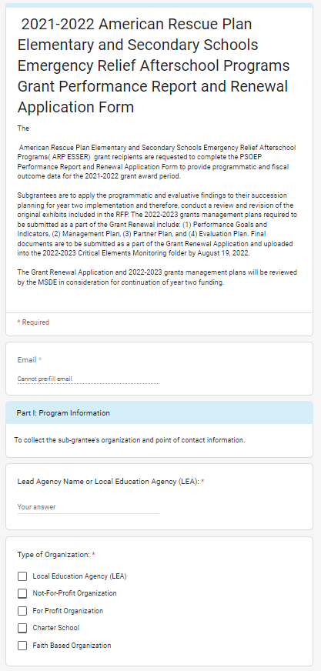

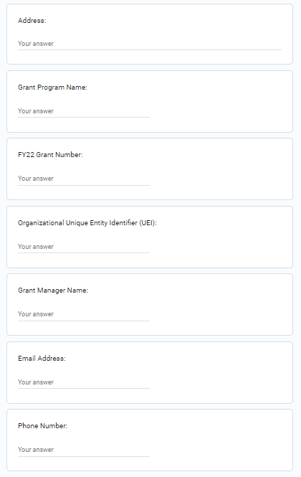

Purpose and design
The grant program purpose and design are reported to align with the federal and state operating requirements.

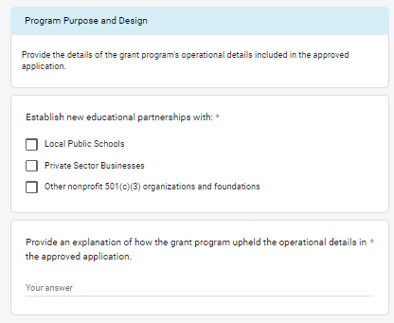

Program operating Details
The program operating details include the reporting of school year or summer operating status, days and hours of operation, and LEA or community site operations.
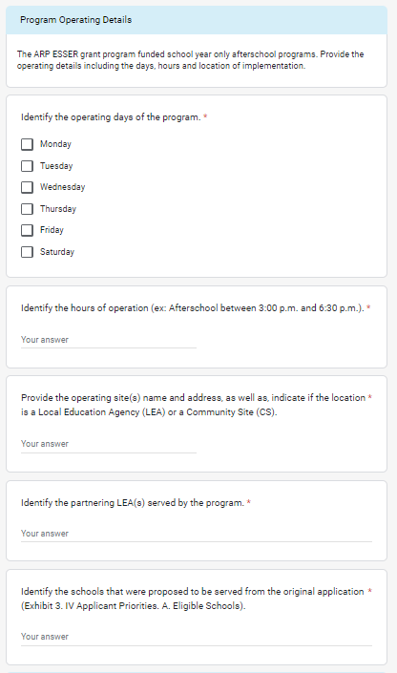

2021-2022 Program calendar
The grant program timeline includes the actual start and end dates of program implementation.
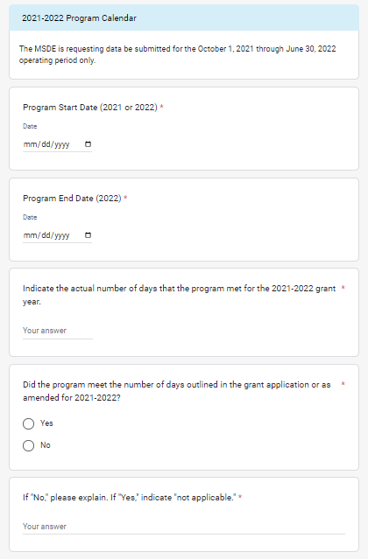

Competitive PriorIty
The applicant may have opted to integrate a competitive priority in the original application. If a competitive priority was implanted the applicant is required to report on the status of implementation.

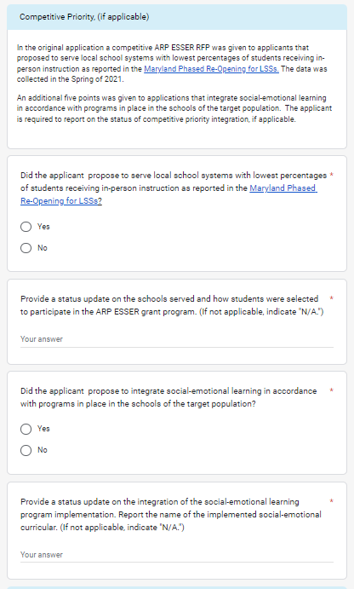

Part II: Student Enrollment and Attendance Data

Student Enrollment
The grant program is to consistently serve at or above 80 percent of the proposed number of students. The OST Critical Elements program evidence and annual collection procedures support targeted outcomes. Implementation year one data is reported for attendance and enrollment.

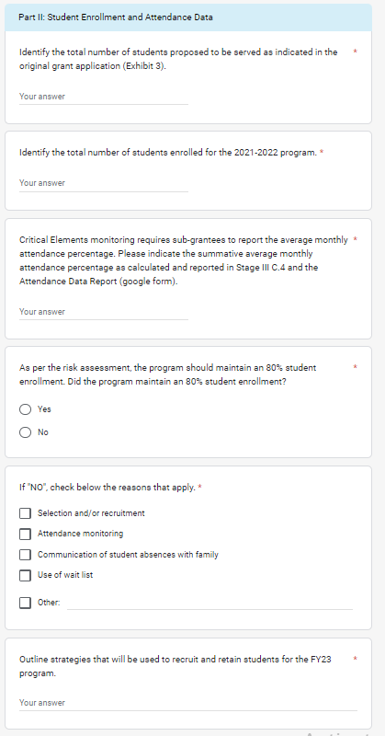

target population
The grant program proposed to serve a target grade level(s). The data collected reflects the proposed and actual grades served.
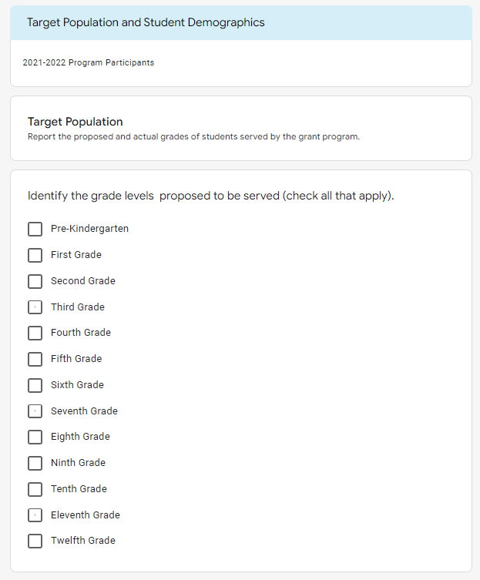
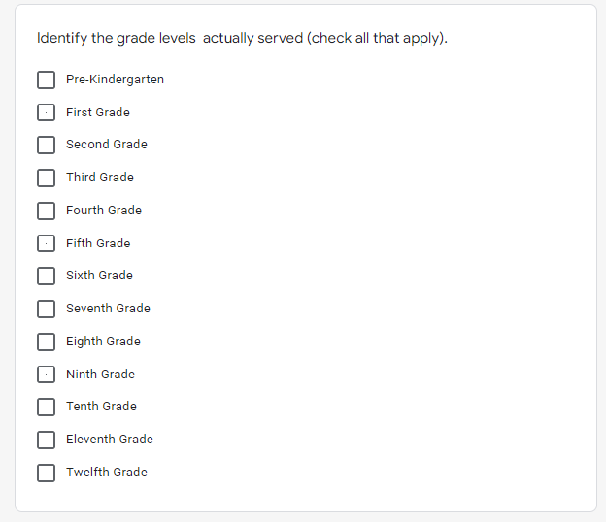

student demographics
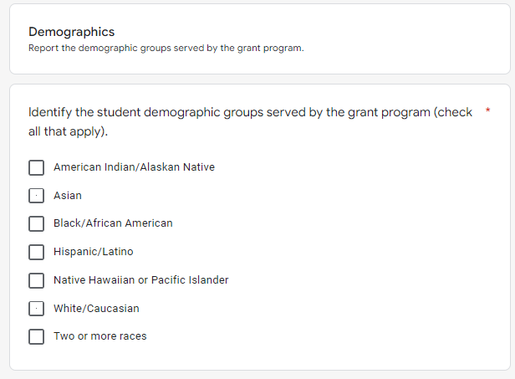
The grant program serves an individualized student demographic.
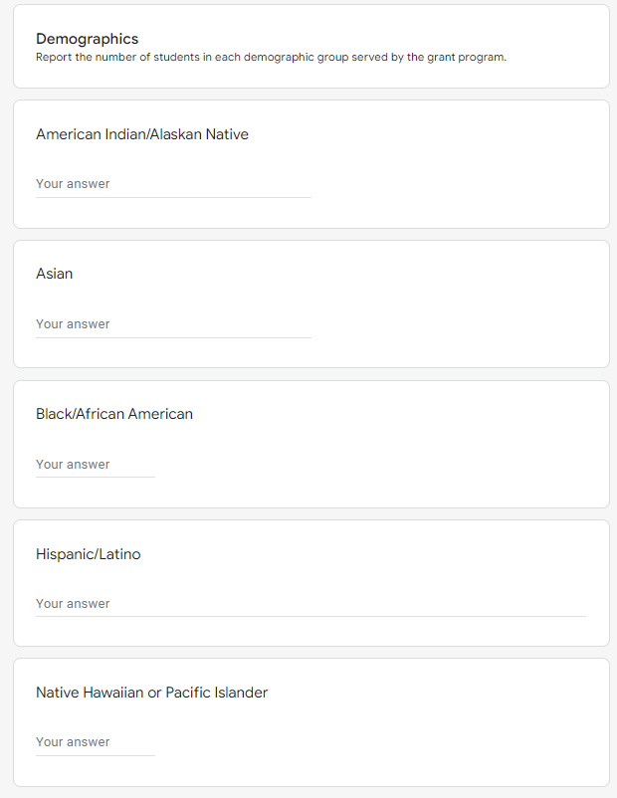
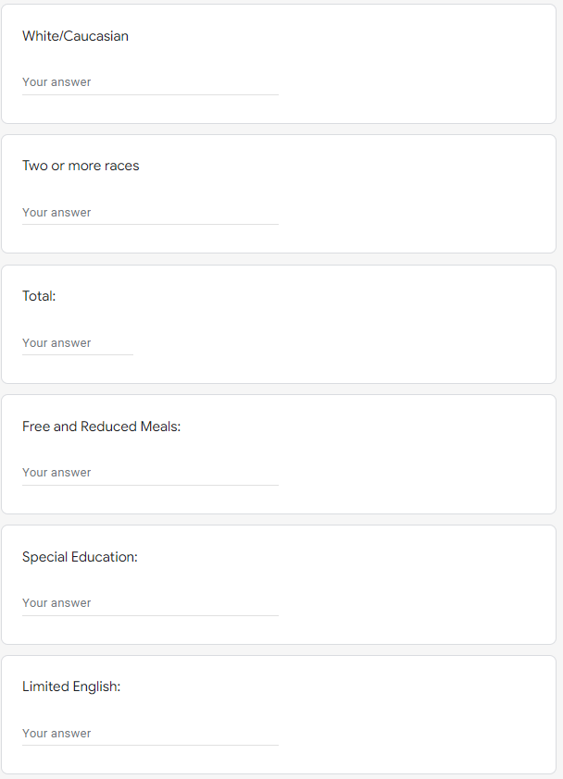

Part III: Performance Goals and Indicators
The MSDE identifies three performance goals to evaluate the effectiveness of the ARP ESSER ASP grant programs. The applicant is responsible for identifying the Performance Indicators, Maryland College and Career-Ready Standards, National Afterschool Association (NAA) Core Knowledge and Competencies for Afterschool and Youth Development Professionals, Activities, Data Source(s) and Evaluation Methods to achieve the specified goal. The applicant must identify the grade level Maryland College and Career-Ready Standards. The National Afterschool Association Core Knowledge and Competencies for Afterschool and Youth Development Professionals include: (1) Child/Youth Growth & Development, (2) Learning Environments & Curriculum, (3) Child/Youth Observation & Assessment, (4) Interactions with Children & Youth, (5) Youth Engagement, (6) Cultural Competency & Responsiveness, (7) Family, School,& Community Relationships, (8) Safety and Wellness, (9) Program Planning and Development, and (10) Professional Development and Leadership.

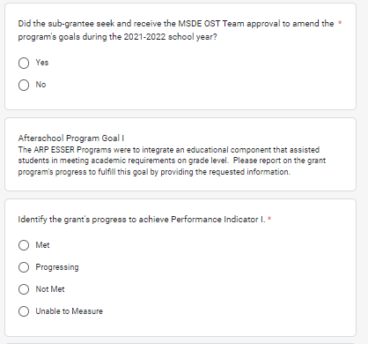

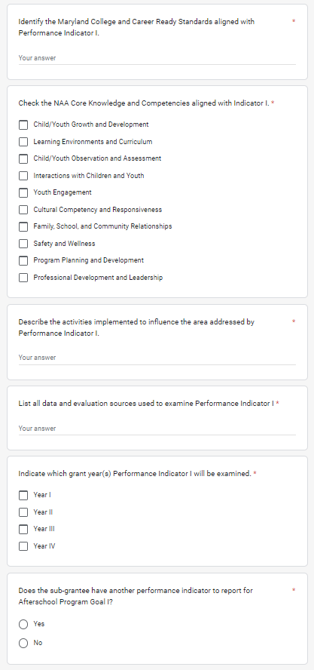
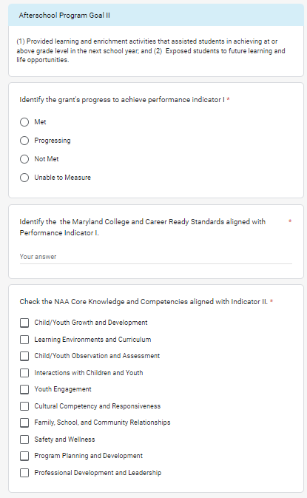
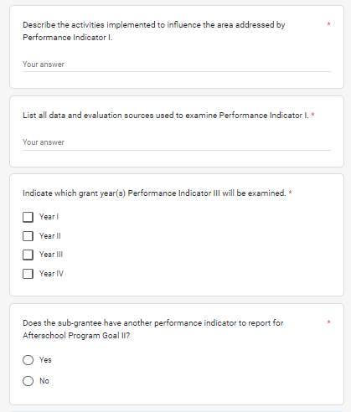

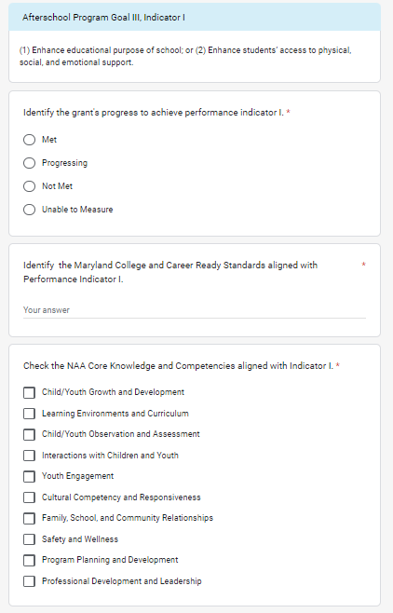

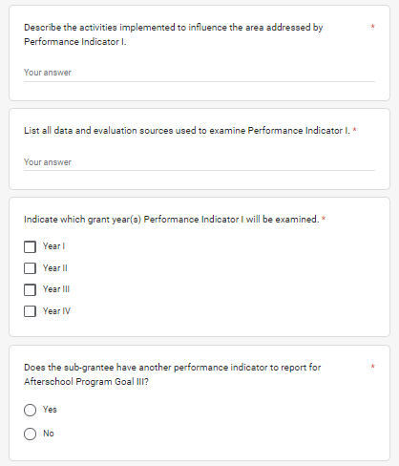

Evidence of impact
The applicant is required to report on evidence-based strategies, impact and effective practices.

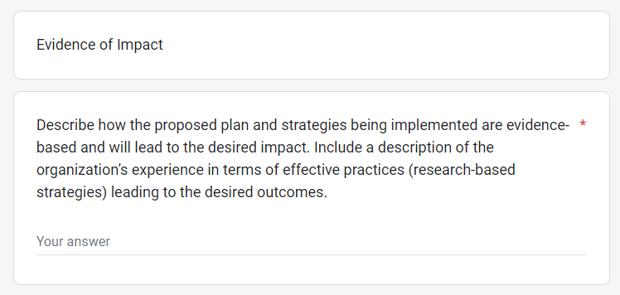

Part IV: Evaluation and Reflection

Evaluation
The applicant is required to conduct an annual evaluation of program effectiveness completed by a local external evaluator. The evaluation report including student performance data is provided to the MSDE by August 31, 2022, for final assessment of the grant program’s effectiveness. At this time, the applicant is required to provide an interim report of the evaluator’s findings regarding the grant program’s best practices.
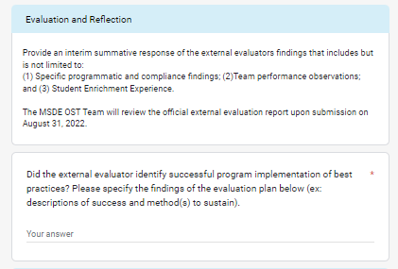

Requested REvision to Performance Indicators
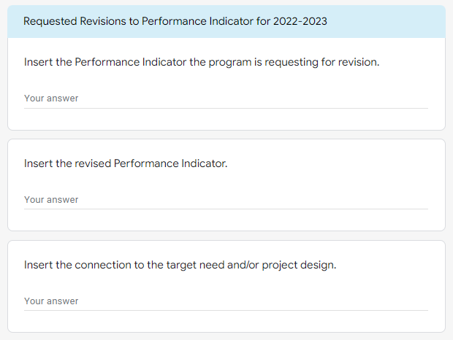
The applicant is encouraged to conduct an ongoing and annual assessment of the evaluation plan and performance indicators. At this time, the grant program is provided an opportunity to request a revision to the original program objectives. Submission of a request does not eliminate the submission of a C-1-25 A to report a programmatic change.

Part V: Collaboration Reflection and Updates

Leadership Team
An annual evaluative reflection of leadership and program staff grant management is encouraged as a best practice.

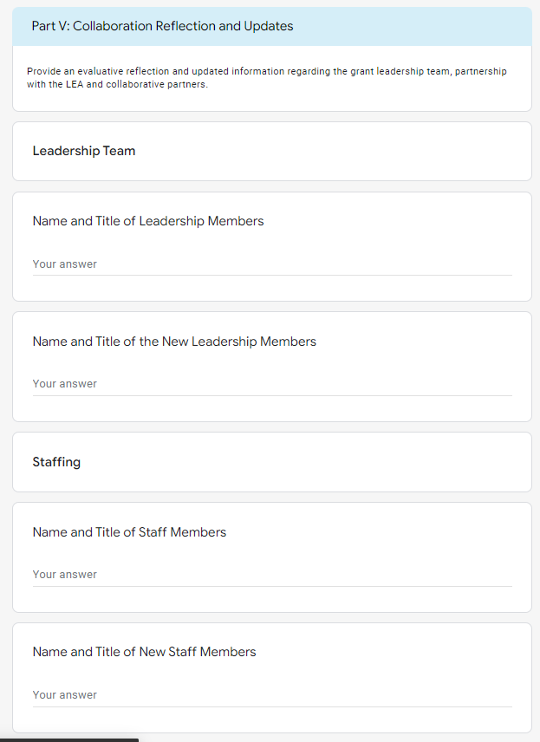

Partnership with the LEA
The data reported in this section reflects the collaborative partnership with the LEA.

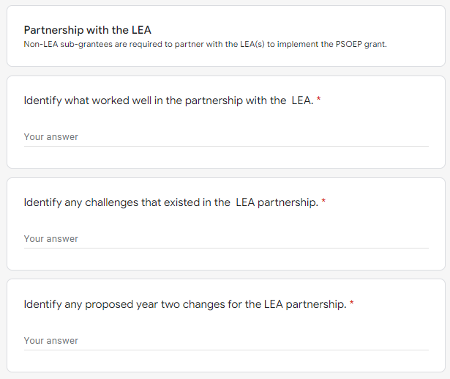

Program partners
Partnerships are an integral component of effective grant implementation. Grant programs are required to reflect and report on the effectiveness of program partners.
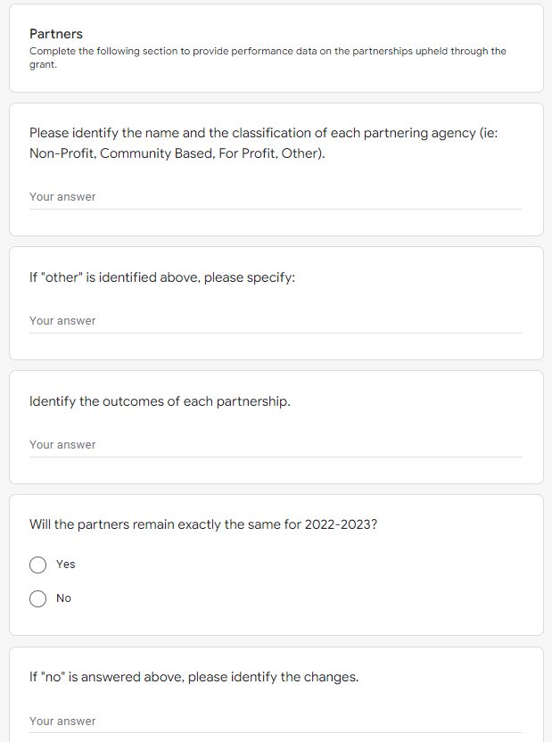

Private and Existing Funding Sources
The MSDE encourages applicants to leverage private and existing funding sources as sustainability practice.
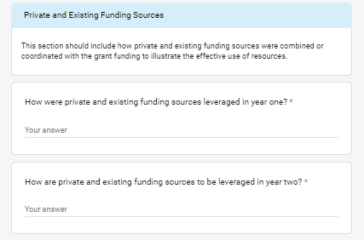

Part VI: Grant Budget Documents (Year II)
Please provide a detailed description of the requested funds that will be spent by using the categories listed below. Add more rows if needed. An MSDE Grant Budget C-1-25 form and Budget Worksheet and Narrative must also be completed, signed, and submitted. Refer to the ARP ESSER Fiscal Grants Guidance: Budget Worksheet and Narrative for additional information.
