

***Maryland State Department of Education***

**Service-Learning Unit**

Lobbying Public Issues

**Primary Subject:** Social Studies - Government

**Grade Level:** 9th or 10th

**Additional Subject Area Connections:**

Reading and Language Arts

**Unit Title:** Lobbying Public Issues

**Type(s) of Service:** Advocacy

**Unit Description:** Students will identify, research, and advocate a public issue that affects their community.

**Potential Service-Learning Action Experiences:**

* Create a public service announcement about the selected issue.
* Write and present a speech on the issue. Collect signatures on a petition.
* Write letters or emails to [congressmen/senators](https://www.house.gov/writerep/) (https://www.house.gov/writerep/).

**Maryland Curriculum Indicators Met**

[**Social Studies**](http://www.marylandpublicschools.org/about/Documents/DCAA/SocialStudies/MSSSS/AmericanGovernmentUnitFramework.pdf)**:**

Indicator

1.4 The student will explain roles and analyze strategies individuals or groups may use to initiate change in governmental policy and institutions.

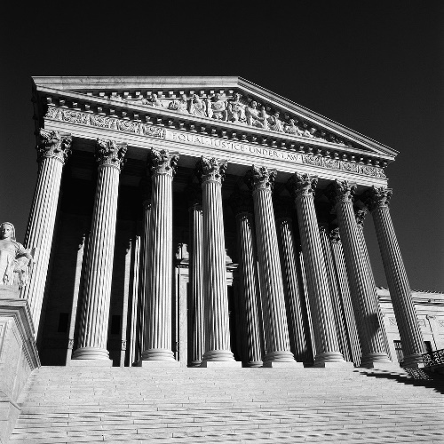

**Alignment with Maryland’s**

**Best Practices of Service-Learning:**

***Lobbying Public Issues***

1. **Meet a recognized community need**

Students will research and select an issue for which to advocate. Issue areas might include:

* Environment (pollution, land use)
* Entitlements & Welfare (Social Security, Medicaid, etc.)
* Health care and public health (costs, substance abuse, diseases)
* Censorship (media, technology)
* Crime (prevention, punishments)
* Equity (race, ethnicity, region, religion, gender, language, socioeconomic status, age, and individuals with disabilities)

1. **Achieve curricular objectives through service-learning**

The student will explain roles and analyze strategies individuals or groups may use to initiate change in governmental policy and institutions.

1. **Reflect throughout the service-learning experience**

Students will engage in-group discussion, brainstorms, debates on the issues and problems, and lobbying, etc.

1. **Develop student responsibility (Students have opportunities to make decisions about the service-learning project.)**

The student will explain roles and analyze strategies individuals or groups may use to initiate change in governmental policy and institutions.

1. **Establish community partnerships**

Student will select community partners based on their issue. Some examples of potential partnerships include:

* [Maryland Department of the Environment](https://mde.maryland.gov/Pages/index.aspx) (https://mde.maryland.gov/Pages/index.aspx)
* [Environment Maryland](https://environmentmaryland.org/) (https://environmentmaryland.org/)
* [Public Policy documents](https://guides.library.yale.edu/publicpolicy/papers) (https://guides.library.yale.edu/publicpolicy/papers)

Welfare

Adult hand helping child’s hand write with a pencil

1. **Plan ahead for service-learning**

Establish advocacy groups, arrange for guest speakers, schedule research and computer lab/media center time.

1. **Equip students with knowledge and skills needed for service**

Students will practice research skills. Students will practice public speaking skills and become knowledgeable about the issues that affect Americans. They will learn how active citizens can impact the community.

**Procedures with Resources:**

***Lobbying Public Issues***

*These procedures represent an example of a service-learning lesson on this specific topic, but can be changed to meet individual classroom interests or varying community needs. You are encouraged to adapt this unit to fit your unique classroom and community and to solicit student input in planning and decision making.*

1. Introduce the service-learning project by discussing service-learning and citizenship with students and engaging in activities to explore those themes. A resource to support this topic can be found at [*Bringing Learning To Life*](https://www.youtube.com/watch?v=o2-eoEi6FCo) (https://www.youtube.com/watch?v=o2-eoEi6FCo).

1. Have students brainstorm current community issues using the list of topics provided. Explain any issues students may not understand. Group students by interest in issue. Allow time for students to research the issue and discuss with group mates. Suggested starting places for research follow:

* [Maryland Department of the Environment](https://mde.maryland.gov/Pages/index.aspx) (https://mde.maryland.gov/Pages/index.aspx)
* [Environment Maryland](https://environmentmaryland.org/) (https://environmentmaryland.org/)
* [Public Policy documents](https://guides.library.yale.edu/publicpolicy/papers) (https://guides.library.yale.edu/publicpolicy/papers)
* [Welfare](https://www.thebalance.com/welfare-programs-definition-and-list-3305759) (https://www.thebalance.com/welfare-programs-definition-and-list-3305759)

**Additional Interdisciplinary Connections**

**MCj03713740000[1]**

Writing

Reading

Speaking

Technology

Mathematics

1. Prepare product (suggestions follow):

* Create a public service announcement about the selected issue.
* Write and present a speech on the issue to a community audience.
* Collect signatures on a petition.
* Write letters or emails to [congress people/senators](congress%20people/senators) (https://www.house.gov/writerep/).

1. Reflection: Create a booklet, brochure, or flyer for distribution. Discuss the impact of the project and what students have learned through the process.
2. Upon project completion, analyze the plan to evaluate the successful completion of the objective and overall success of the project. Also, reflect on the project using various reflection activities and evaluate the effectiveness of the project by completing the [*Rubric for Assessing the Use of the Maryland’s Seven Best Practices of Service-Learning*](http://marylandpublicschools.org/programs/Documents/Service-Learning/rubric_best.pdf)(http://marylandpublicschools.org/programs/Documents/Service-Learning/rubric_best.pdf).

*Updated: October 2019, December 2014; Created: July 2007*

Division of Student Support, Academic Enrichment, and Educational Policy

Youth Development Branch

200 West Baltimore Street

Baltimore, Maryland 21201

410-767-0357

[Maryland Public Schools Service-Learning Website](http://www.mdservice-learning.org) (www.mdservice-learning.org)

[Maryland Public Schools](http://www.marylandpublicschools.org/) (www.marylandpublicschools.org)

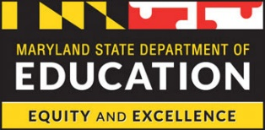

*\*This material is based upon a template for service-learning experiences created by the Maryland State Department of Education. Opinions or points of view expressed in this document are those of the authors and do not necessarily reflect the official position of the Maryland State Department of Education or constitute an endorsement.*