Technical Assistance Bulletin
Division of Early Intervention and Special Education Services | Bulletin # 18-04
Birth – Age 4 Birth – K Age 3 – K Birth – 21 Age 3 – 21
Date: Revised November 2019

Secondary Transition
Section 1: Legal Policy

Assessing, Collaborating, and Implementing
Secondary Transition is the process of preparing students for adult life after they leave high school. Transition planning begins in Maryland at age 14 as students explore and discover what they want their post-school goals and outcomes to be through career awareness activities. The transition process continues through high school as academic instruction and community experiences support these outcomes. This process considers the student’s strengths, preferences, and interests. Transition is designed to be within a results-oriented process which focuses on improving the student’s academic and functional achievement, while facilitating student’s movement from school to post-school activities. Seamless transition occurs when the services, supports, and connections through high school are already in place with opportunities in adult life. Secondary transition educators facilitate students and their families through the transition process by connecting them to various opportunities such as higher education or training, independent living, employment, and community participation.

The Individuals with Disabilities Education Act (IDEA) ensures that all children with disabilities have available to them a free appropriate public education (FAPE) that emphasizes special education and related services designed to meet their unique needs and prepare them for further education, employment and independent living [20 USC §1400 (d)(1)(A); 34 CFR §300.1(a)]. The IDEA’s focus on preparing students for the future is embodied in its requirements related to transition planning. Developing and executing a meaningful transition plan is required to ensure that students with Individualized Education Programs (IEPs) are prepared for the post-high school challenges they will encounter. A transition plan will address instruction, related services, community experiences, and the development of employment and other post-school adult living objectives. Where appropriate, the plan will include acquisition of daily living skills and provision of a functional vocational evaluation. Transition services for students with disabilities may be special education, if provided as specially designed instruction, or a related service, if required to assist a student with a disability to benefit from special education.
[20 USC §1401(34); 34 C.F.R. §300.43; COMAR 13A.05.01.03B (80)]

Frequently Asked Questions
- When does transition planning begin for students with disabilities?
In Maryland, a student’s IEP must include transition services beginning no later than the first IEP to be in effect when a student is age 14. This requirement in Maryland exceeds the federal requirement under IDEA, which is that transition is to begin at age 16 [34 CFR 300.320]. The IEP may include transition services for students who are younger than age 14, if appropriate. The transition plan must be updated annually. The student’s IEP shall include a Transition Plan which contains:
- Transition services, including course of study needed to assist the student in reaching those goals;
- Appropriate measurable postsecondary goals based on age-appropriate transition assessments related, as appropriate, to training, education, employment, and independent living; and
- A statement of needed transition services before the student leaves the secondary school setting, including, where appropriate, a statement of the public agency’s responsibilities or linkages, and the participating agency’s responsibilities or linkages, or both.
[Education Article §21-305, Annotated Code of Maryland; COMAR 13A.05.01.09A (3) (a)]

- Who should be invited to the IEP team meeting if a purpose of the meeting will be the consideration of the postsecondary goals and the transition services needed to assist the student in reaching those goals?
The school must invite local school system personnel and the parents, as it would with any other IEP team meeting. For the specific purposes of transition planning however, the school must:
- Invite the student. If the student does not attend the IEP team meeting, the school must take other steps to ensure that the student’s preferences and interests are considered. The student should be encouraged to participate in the IEP meeting, and the local school should make provisions and accommodations for the student to provide input during the meeting at which point postsecondary goals and transition services are discussed.
- Invite participating agencies. With the consent of the parents, or with the consent of a student who has reached the age of majority consistent with Education Article §8-412.14, invite a representative of any participating agency that is likely to be responsible for providing or paying for transition services. Parental consent is required for invitations to participating agencies. Each time local school system/public agency (LSS/PA) personnel want to invite an agency representative to a student’s IEP team meeting, the LSS/PA must seek and receive consent prior to inviting such a representative. Such consent must be obtained before each meeting, as confidential information about the child is always shared. If an invited representative of a participating agency does not attend the meeting, the public agency must take other steps to obtain the involvement of the agency in the planning and provision of transition services. Furthermore, because the discussions held at each meeting are not the same, each meeting may require different or additional participants. [34 CFR §300.321(b); COMAR 13A.05.01.07A (3-5)]

- What must be included within a student’s IEP?
Each student’s IEP, beginning at age 14 and annually thereafter, must include documentation of the following:
- Evidence of age-appropriate transition assessments. Evidence must include testing scores and summary of recommendations;
- Appropriate measurable postsecondary goals in employment, education/training, and independent living, if appropriate;
- Annual IEP goals related to the student’s transition service’s needs;
- Transition services;
- Courses of study, that will reasonably enable the student to meet those postsecondary goals; and
- There also must be evidence that:
  - The student was invited to the IEP Team meeting where transition services are to be discussed;
  - The parent, or the student who has reached the age of majority, provided consent to invite a representative of any participating agency, if appropriate, and was invited to the IEP team meeting; and
  - The representative of any participating agency was invited to the IEP team meeting following receipt of consent to invite. [20 USC §1416(a)(3)(B)]
[34 CFR § 300.320(b); 34 CFR § 300.321(b); COMAR 13A.05.01.09A (3); COMAR 13A.05.01.07A (3)]

- What is a measurable postsecondary goal?
A measurable postsecondary goal is an outcome that occurs after the person has left high school. The path toward achieving the goal, however, occurs before the student leaves school. Indeed, this is the function of transition services as outlined in a student’s transition plan. It is measurable if it is stated in a manner that can be counted as occurring or not occurring. Statements that indicate what a student “will” do indicate measurable postsecondary goals. Statements that indicate that a student “plans to” or “hopes to” or “will investigate” do not indicate measurable postsecondary goals.

Examples:
Employment
- Upon graduating from high school, student will be employed in the field of health care.
- Student will be employed in the retail field with support after graduating from high school.
Education or Training
- Upon graduating from high school, student will attend a 4-year college to complete a course of study that prepares her for employment in the field of health care.
- Upon graduating from high school, student will participate in a 2-year supported employment training program to earn a certification in culinary arts.
Independent Living
- Upon graduating from high school, student will continue to live at home while participating in a travel training program provided by (name of agency).
- Upon graduating from high school, student will participate in money management skill building given support/training provided by (name of community resource provider).
Non-Examples:
Employment
- Student plans to enter employment in the field of health care.
- Student hopes to be employed in the retail field with support after exiting school.
Education or Training
- Student will apply to college and plans to major in health care.
- Student would like to be in a supported employment training program after she leaves school.
Independent Living
- Student would like to learn how to use public transportation.

- Is the school liable if the student does not meet his or her postsecondary goals?
No. The LSS/PA has a statutory obligation to provide transition services to assist a student in attempting to reach his or her measurable postsecondary goals, but the IDEA does NOT hold the LSS/PA liable in the event that the student does not, in fact, achieve those goals. The stated measurable postsecondary goals are required components of transition planning, and yet there are numerous mediating factors that positively or negatively affect an adult’s achievement of goals for which a school could not be held accountable. As required by IDEA and COMAR, a student’s progress toward annual goals must be documented in the IEP and shared with parents on a regular basis. In Maryland, progress on individual transition services/activities must be documented and shared in the same fashion. Ultimately, the IDEA requires that a student’s education program supports his or her desired goals for education/training, employment, and independent living, if appropriate, beyond secondary school. [34 C.F.R. § 300.320(a) (3); COMAR 13A.05.01.09B]. For more information, visit the National Technical Assistance Center on Transition www.transitionta.org and National Youth Transitions Center http://nationalyouthtransitionscenter.org/.

- What are transition services?
“Transition services” are a coordinated set of activities for a student with a disability that are:
- Designed to be within a results-oriented process, focusing on improving the academic and functional achievement to facilitate the student’s movement from school to post-school activities, including postsecondary education, vocational education, integrated employment (including supported employment), continuing and adult education, adult services, independent living, or community participation; and
- Based on the individual student’s needs, considering the student’s strengths, preferences, and interests, and may include but are not limited to:
- Instruction;
(ii) Related Services;
(iii) Community Experience;
(iv) Travel Training
(v) The development of employment and other post-school adult living objectives; and
(vi) If appropriate, acquisition of daily living skills and provision of a functional vocational evaluation.

- Where is transition addressed in a student’s IEP?
Within the Maryland Online IEP form, the components of Secondary Transition are located in Section II – Present Level of Academic Achievement and Functional Performance (age appropriate transition assessment); Section III – Special Considerations and Accommodations; Section IV – Goals and Section V – Services. The considerations to be addressed include the following:
- Transition Assessments can now be uploaded and attached to a child’s IEP record in Student Compass.
- Age-appropriate transition assessment(s). Reference should be made to these pages for assessment scores that are needed as part of a transition assessment.
- Student preferences and interests
- Date of student interview
- Postsecondary Goals (Outcomes) – Annually, there is a required minimum of two postsecondary goals. One of the two goals must address training or education and the second goal must address employment. Postsecondary goals in independent living are addressed, where appropriate. COMAR 13A.05.01.09 *When determining the appropriateness of including independent living postsecondary goals, there are a few questions to ask that may support the IEP Team’s decision:
- Does the student require transition planning or services that will help him/her to function independently after graduation? This could include the areas of housing, home maintenance, personal care, transportation, mobility, communication, social interaction, self-advocacy, recreation/leisure, and community participation.
- Are there related services in the IEP that will impact the student's independence and daily living after graduation? Should there be transition planning and services in this area?
- If there is a question about whether or not a postsecondary goal for independent living is appropriate, the administration of Independent Living and Self-Determination assessments will provide specific information as to the student's areas of strength and needs to successfully transition to adulthood.
- Course of Study
- Projected Date of Exit
- Projected Category of Exit
- Agency Linkages/Referral
- Transfer of Rights, as applicable
- Transition Services/Activities – A coordinated set of activities that is designed to facilitate the student’s movement from school to post-secondary activities to address, as appropriate: academic; employment training; activities of daily living; independent living; and transportation. There must be at least one transition service/activity that supports each postsecondary goal. There must be at least one academic activity and one employment/training activity that supports the postsecondary goals. Each of the various transition activities must complement and be coordinated with each other. Transition services/activities are reviewed annually.
- Anticipated Services for Transition – Services the IEP team anticipates that the student will need within one year of exiting school.
- IEP Goal(s) for the special education and/or related services to address the student’s needs, that focus on improving academic and functional achievement that is linked to the student’s desired postsecondary goals (outcomes) and course of study.
- Special Education Services
- Related Services
- Career and Technology Services

- What is the difference between an annual goal and a postsecondary goal?
Measurable postsecondary goals are different from measurable annual goals in that they measure an outcome that occurs after a student leaves high school where measurable annual goals measure annual progress of the student while still in school. It is important to note that each postsecondary goal must be supported by one or more annual goal and each annual goal may support more than one postsecondary goal. IEP teams should understand what annual goals support the postsecondary goal.

9. When are students connected to participating agencies for the purpose of determining eligibility?
The initial linkage to participating agencies begins by providing the student and parent with a copy of the “Transition Planning Guide” when a student begins transition at age 14. This guide is to be provided at each IEP team meeting where Transition is discussed. The parent and student are asked to sign for their receipt of the Guide. The receipt must be filed in the student’s special education folder. With parent consent, students should be connected to the appropriate agency or program of individual student choice considering individual preferences, circumstances, and IEP transition goals, as well as the agency’s referral protocols as recommended by the IEP team. The activities occur during specific times of the transition process timeline and can be found in the Secondary Transition Planning Guide for Individuals with Disabilities. (http://marylandpublicschools.org/programs/Documents/Special-Ed/MDTransitionPlanningGuideforIndividualswithDisabilities.pdf)
- The Division of Rehabilitation Services (DORS) requests that students be referred to that agency for traditional VR services during the spring of the school year prior to the student’s last year in school. The referral may be made at some other time based on local interagency agreement.
- The Developmental Disabilities Administration (DDA) requests that beginning when students turn age 14 as part of the transition process, anticipated eligibility for DDA will be discussed. Information on how and when to apply for DDA services will be provided by your IEP team. *Application to DDA may occur at any time prior to age 14.
- The Behavioral Health Administration (BHA) requests that students be linked with that agency prior to the student exiting school.
- The Maryland Department of Labor (formerly Office of Workforce and Development and Adult Learning, Department of Labor, Licensing, and Regulation) serves young adults with and without disabilities, ages 14-24. Services can be access through Maryland’s 32 local American Job Centers. There is not a referral process for DLLR https://www.dllr.state.md.us/county/.

- What is the difference between “entitlement” and “eligibility” as it relates to the availability of services after exiting school?
In Maryland, a young adult with a disability who is receiving special education and related services is ENTITLED to a free appropriate public education through the end of the school year in which he or she turns 21 years of age. This entitlement ends when the student graduates with a Maryland High School Diploma or has reached age 21 and graduates with a Maryland High School Certificate of Program Completion. If a student graduates with a certificate prior to age 21, then it is with the agreement of the student and parents, both acknowledging that the student is ready to transition into the world of work, including but not limited to: gainful employment, postsecondary education and training, supported employment, and other services that are integrated in the community. See 34 C.F.R. § 300.102 & COMAR 13A.03.02.09E (1). Once one of these events has occurred, the responsibility of receiving services shifts to the young adult. At this point the young adult must apply for services to see if he or she is ELIGIBLE to receive them based on the eligibility criteria of the various agencies and programs. In addition to meeting eligibility criteria, the young adult must make sure there is funding available for services and supports from adult service agencies. This change in responsibility is at the heart of the transition process that happens when students go from entitlement programs to eligibility programs.
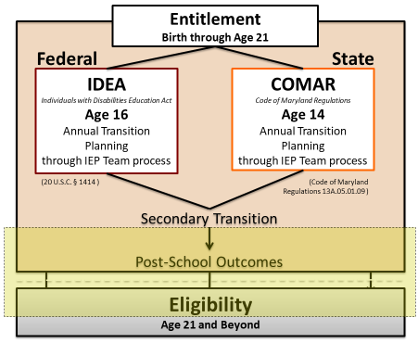

- Are there documents that students with IEPs must receive prior to exiting school?
Yes. IDEA and COMAR require each student who exits special education to receive a Summary of Performance (SOP). COMAR 13A.05.01.06E (11). The language as stated in IDEA regarding the SOP is as follows: For a child whose eligibility under special education terminates due to graduation with a regular diploma, or due to exceeding the age of eligibility, the local education agency “shall provide the child with a summary of the child’s academic achievement and functional performance, which shall include recommendations on how to assist the child in meeting the child’s postsecondary goals” 34 CFR § 300.305(e) (3). The purpose of the SOP is to provide the child with a summary of the student’s academic achievement and functional performance in order to assist them to transition beyond high school. In Maryland the Maryland Summary of Performance (MSOP) is generated as a report, similar to other reports (e.g. Academic achievement, functional performance, accommodations, and progress on transition services/activities) and shared with the student and family.

While our federal and state law requires the Maryland Summary of Performance (MSOP) report to be given to the student and his/her family at the time of graduation, we highly recommend using this report as a diagnostic tool to evaluate the quality of transition plans for students prior to their year of graduation. This will ensure that all components in the IEP are used to develop a student-centered transition plan based on the student’s strengths, needs and goals.

- What is a Graduation Cohort?
Students who are entering grade 9 for the first time form a cohort that is subsequently “adjusted” by adding any students who transfer into the cohort later during the next three years and subtracting any students who transfer out, emigrates to another country, or dies during that same period. This definition is defined in federal regulation 34 C.F.R. §200.19(b) (1) (i)-(iv). What this means in practice is that the goal for any student, including those with IEPs, is that the student will graduate in 4 years. Extending graduation beyond 4 years should only be considered when the unique needs and extenuating circumstances of the student are so great that even with significant supports and interventions additional time will be required to meet graduation requirements. The discussion surrounding Graduation Cohort should occur annually and changes to and rational for these changes to the cohort should be clearly documented in the IEP.

- Where may students, parents, and school personnel find additional technical assistance related to secondary transition?
In Maryland, there is an active statewide website that includes resources, information, and tools to assist teens, families, schools, and communities for future possibilities pertaining to employment, access to postsecondary education, and their communities. The website address is https://mdtransitions.org/. Nationally, the Office of Special Education Programs (OSEP) has funded the National Technical Assistance Center on Transition (NTACT) to aid in the area of transition planning. The website address for NSTTAC is www.transitionta.org. The National Youth Transitions Center provides information specific to youth with persons with disabilities beginning in middle school through age 30. The website address for National Youth Transitions Center is http://nationalyouthtransitionscenter.org/.

- What is Secondary Transition Federal Indicators and why are they important?
The State must have in place performance indicators through which it reports progress to the U.S. Department of Education. Four of the indicators are referred to as the secondary transition indicators. The four secondary transition indicators include the:
- Percent of youth with disabilities who graduate with a regular diploma (Indicator 1),
  - Percent of youth with disabilities who drop out (indicator 2),
  - Percent of transition age youth (14 and above) whose IEPs contain all the required transition components (Indicator 13), and
  - Percent of youth with disabilities who achieve various postsecondary outcomes in education and employment (Indicator 14)
There is a critical relationship between the four secondary transition indicators. Collectively, they form the basis for examining in-school programs and recognizing the connection between what youth experience in-school and the influence on what student’s experience after they leave school.

- Are there changes to legislation that impact youth receiving secondary transition services?
In July 2014, the Workforce Innovation and Opportunity Act (WIOA) was signed into law. WIOA replaces the Workforce Investment Act of 1998 (WIA) and amends the Rehabilitation Act of 1973. WIOA requires vocational rehabilitation (VR) agencies to set aside at least 15% of their federal funds to provide “pre-employment transition services” (Pre-ETS) specifically to “Students with Disabilities.” The limited pre-employment transition services that may be provided based on identified need and the availability of services includes:
- Work-based learning experiences, which may include in-school or after school opportunities, experiences outside of the traditional school setting, and/or internships
- Job exploration counseling
- Counseling on opportunities for enrollment in comprehensive transition or post-secondary educational programs
- Workplace readiness training to develop social skills and independent living
- Instruction in self-advocacy

For additional information or to refer for Pre-ETS services visit: www.dors.maryland.gov.

Secondary Transition
Section 2: Implementation

Introduction
Knowing the power of Secondary Transition practices to narrow the existing gaps to meet outcomes we have made Secondary Transition one of three action imperatives outlined in the Division of Early Intervention Services and Special Education Services (DEI/SES) Strategic Plan Moving Maryland Forward (See graphic below).

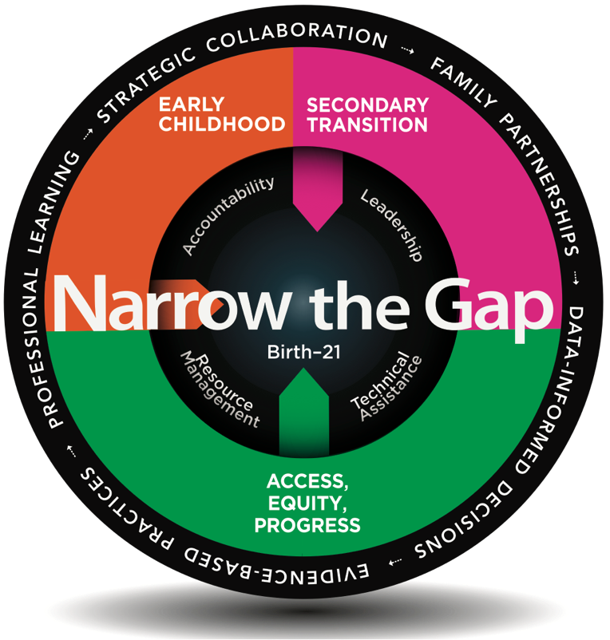

What we have determined is that systemic change requires not just knowledge of what is legally required, but also the implementation of policies and procedures that work. We know that high expectations, early transition planning (MD begins at 14), family partnerships, self-advocacy, and EBPs are key predictors to those positive outcomes. There has been significant research over the last four decades around secondary transition in an attempt to identify predictors of post-school success for youth with disabilities.

Many of the effective strategies as outlined in the DEI/SES Strategic Plan Moving Maryland Forward are summarized below:
- Youth need individually designed transition plans to document their high school experiences, establish specially designed goals for exploring post-secondary education and career preparation, and obtain services and supports.
- Effective transition services for students with disabilities should include workforce training, paid employment, higher education and technical education—all provided by knowledgeable transition service professionals.
- Paid work experiences while in secondary education are the most compelling predictor of post-school success.
- Instruction in self-determination and self-advocacy results in informed decision-making such as accommodation needs, disclosure decisions, and career preferences.
- Cross-system and cross-agency collaboration supports customized employment and pathways to college, agency linkages, and access to full community integration.

Ultimately, a student’s first day of adulthood should be no different than his or her last day of high school, resulting in a seamless transition. While transition must begin at age 14, it is truly part of a continuum, as illustrated below. Maryland has applied what we know about secondary transition to develop and support implementation of policies and practices across the state.
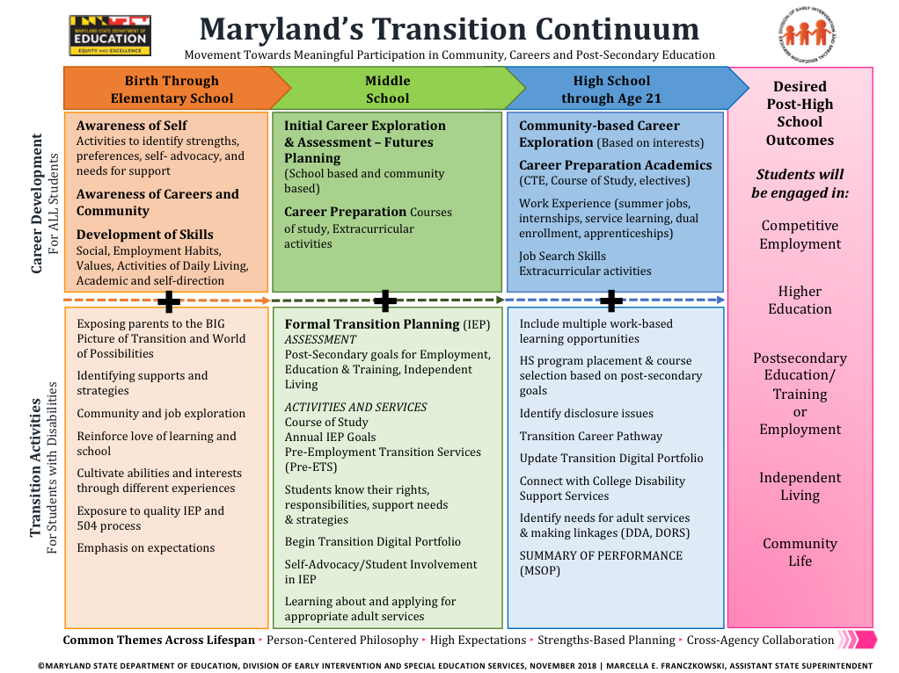

Maryland’s Secondary Transition Process
Ensuring that meaningful secondary transition plans are included in the IEP is a critical component that addresses the legal requirement of the Individuals with Disabilities Education Act (IDEA) for students with IEPs beginning the year they turn 14 years of age through the year they turn 21 years of age. As Maryland’s local school systems, secondary transition leadership teams, and liaisons from the State collaborate to implement a Secondary Transition System of Coordinated Services, a framework has emerged that focuses on customized strategies that support purposeful transition planning leading to positive outcomes for youth with disabilities.
The three components (Development, Implementation, Evaluation) of the secondary transition planning process support the delivery of Specially Designed Instruction (SDI) as it provides students with disabilities the opportunity for more intensive instruction in areas of skill deficits, alongside their peers. SDI is planned, organized, and meaningful. It is a purposeful and systematic approach to addressing a student’s needs based on their current performance and the impact of their disability on learning and making progress (34 CFR §300.39 (b) (3)).
Once students have reached the age of transition (14 years of age), the IEP should consider the student’s desired postsecondary goal and develop transition services/activities that support progress towards their post-school outcomes. There should be a relationship between the specially designed instruction provided to the student and the progress of the goals and activities as evident in the transition plan. In fact, it is the role of the IEP team to thoughtfully and intentionally consider how the SDI can influence or change the trajectory of the student’s progress toward reaching their post-secondary goals.
Specially Designed Instruction as it relates to transition planning can be found in the “Transition Activities” section of the IEP document. These transition activities are identified and written for the student based on their assessed interests, preferences, strengths and needs. They are designed to be completed within the year of the IEP and are monitored for progress quarterly.
The graphic below includes the required components of the transition plan in the IEP and the alignment to data, evidence-based practices with fidelity, and monitoring as local teams develop, implement, and evaluate their secondary transition system of coordinated services.

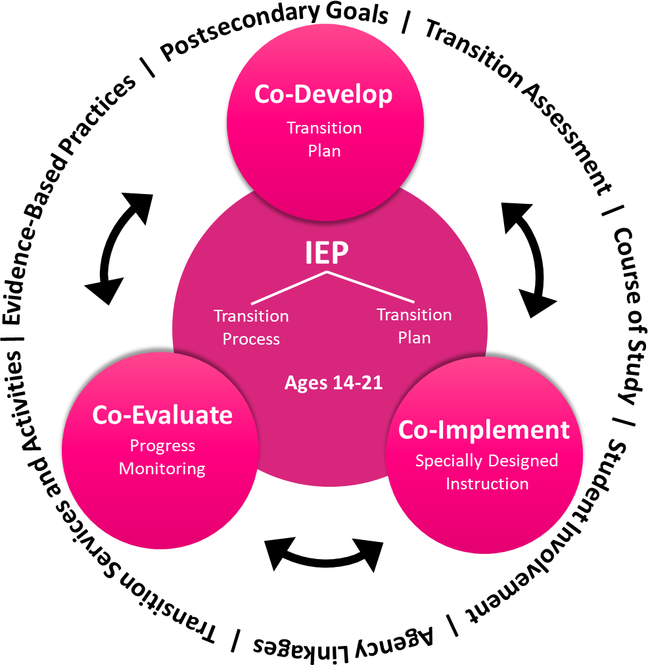

The Guide for Implementing the Secondary Transition Process serves as a guidance document to develop, implement, and evaluate the secondary transition process beginning at age 14 and equally important the writing of effective, purposeful transition plans that align with the requirements of IDEA and COMAR and identify best practices. To access a copy of the tool, please visit: https://marylandlearninglinks.org/st/

Maryland’s Employment First
Employment First is a national initiative that seeks to realign systems and values to support the idea that all people, including people with the most significant support needs, can work when given the proper support. Maryland is an Employment First state, which means that we operate from a strategic plan which outlines the strategies to support the intended outcomes of employment. This policy identifies integrated competitive employment as the “first” service to be explored for individuals with developmental disabilities who receive DDA services. It is aligned with several predictors of post-secondary success, including work experiences, paid employment, and access to effective transition programs. A large part of this systems transformation focuses on building capacity among employment providers to support the path to employment in competitive integrated employment, as opposed to more historical models that include congregate settings, like sheltered work. In 2007, Maryland joined the State Employment Leadership Network (SELN) and, since then, a number of key stakeholders have been working to implement an Employment First policy across the state. Some of the key stakeholders include the Division of Rehabilitative Services (DORS) and the Developmental Disabilities Administration (DDA). Such partnerships are essential if Maryland is to build and maintain a seamless transition system.

Consistent with effective transition planning, Maryland providers use a process called “Self-Discovery and Customization,” which takes a detailed look at a person’s interests, abilities, and environmental needs, and uses an interactive process of hands-on exploration to identify a person’s employment goals. The process also considers employers’ needs so that there is a mutually agreed upon match of skills and tasks. In this way, Employment First supports the need for youth with disabilities to access a variety of work-based learning experiences and employment opportunities, as outlined in a student’s transition plan.

It is also important to note that federal changes to Home and Community Based Waivers, which fund DDA services, now require individuals to be served in the most integrated setting possible and, if they are employed, to be paid at or above minimum wage. Maryland’s State legislature has also supported this effort in the passage of the Ken Capone Equal Employment Act in 2016 which prohibits labor and industry from authorizing work activities centers from paying disabled employees less than the minimum wage. This means that many of the traditional post-school options available to youth with disabilities and their families, such as Day Habilitation and Sheltered Workshops, are changing to align with these new requirements. It is essential that both schools and families understand these changes so that they are fully equipped to explore options for inclusive transition programs that include integrated competitive employment.

For additional information, visit:
Maryland’s Employment First
http://mdod.maryland.gov/employment/Pages/employment-first.aspx

Maryland Developmental Disabilities Administration
https://dda.health.maryland.gov/Pages/HCBS.aspx

Way2 Work Maryland
Way 2Work aims to improve the lives of students with disabilities in Maryland by increasing their academic, career, and financial success. The purpose is to enable local school systems to implement a model of school to career transition services for students with disabilities. This model incorporates four evidence-based components associated with post-school success: 1) early engagement with the Division of Rehabilitation Services (DORS) Pre-Employment Transitioning Services (Pre-ETS); 2) multiple work experiences; 3) paid employment; and 4) focused collaboration among schools, DORS, local community rehabilitation providers (CRPs), workforce centers, and other partners.

Maryland has leveraged federal grant funds to develop this model. The identified outcomes for the Way2Work Maryland is to: 1) improve competitive integrated employment consistent with students’ career goals; 2) increase economic self-sufficiency; 3) ensure high school completion and linkages to post-school services and supports consistent with students’ goals; 4) improve service system collaboration to reduce systemic barriers and sustain effective service coordination; and 5) demonstrate the efficacy of the model to improve outcomes and impacts of youth with disabilities for replicability and sustainability. Maryland is committed to implementing policies aligned with predictors of post-school success and taking what works to scale.

Way2Work MD will be ending June 2020.

For additional information, visit:
Way2Work Maryland
https://www.way2workmd.net/

Predictors of Post-School Success
Through rigorous research, the National Technical Assistance Center on Transition (NTACT), funded by the U.S. Department of Education, has identified a number of predictors of post-school success. The NTACT defines predictors as an “in-school experience, typically a program (i.e., work-based learning experience) that correlates with improved post-school outcomes.” Below is a listing of various predictors and the different post-school outcomes they support (i.e. education, employment, and/or independent living). https://www.transitionta.org/sites/default/files/Pred_Outcomes_0.pdf
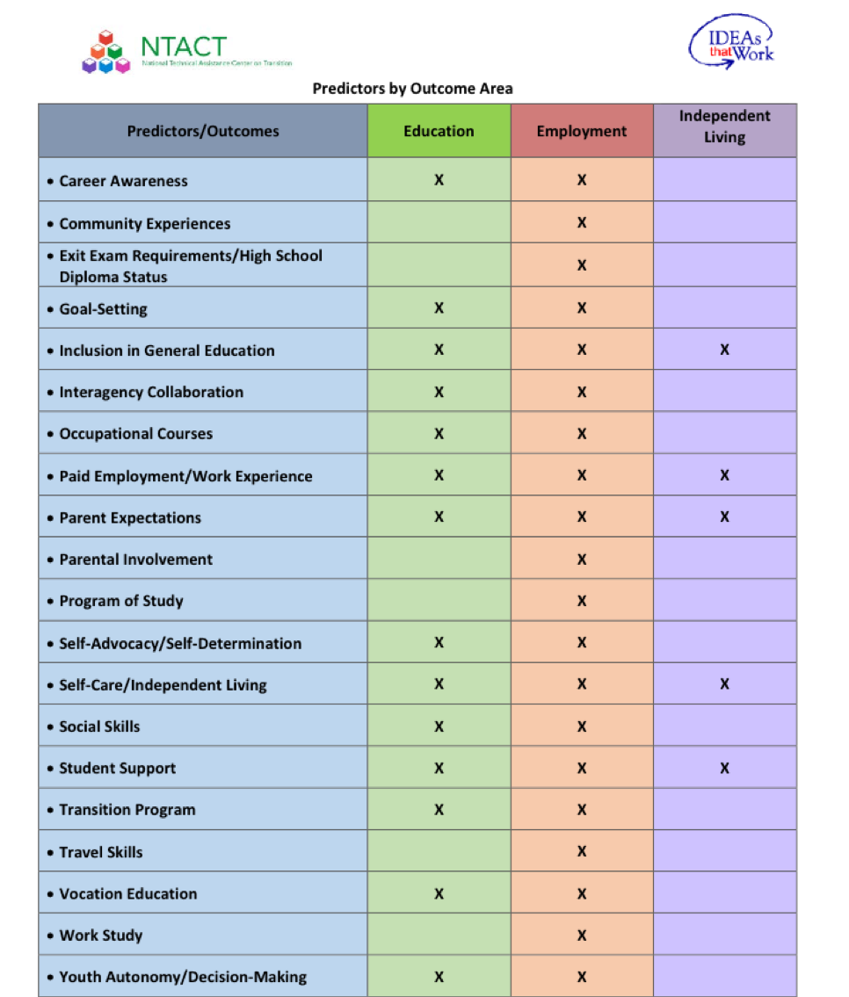

https://www.transitionta.org/sites/default/files/Pred_Outcomes_0.pdf

Some of the identified predictors adopted in Maryland – particularly in the DEI/SES’s strategic plan and implementation strategies – include: career awareness, paid employment, work-based learning, vocational education, community experiences, self-determination/self-advocacy, interagency collaboration, and parent expectations. The predictors of post-school success have been embedded at the State level to support implementation at the local level.

State Initiatives and Technical Assistance
To improve post-school outcomes, the DEI/SES offers professional development to local school systems on using data to: 1) inform instructional decisions and the development of quality transition IEPs; and 2) evaluate existing transition programs and activities in relation to evidenced-based best practices. The DEI/SES also supports engagement of America’s Job Centers (formerly known as One Stops) and use of tools such as Social Security Administration (SSA) 301, which allows youth on SSI to delay a redetermination while on an approved plan for employment. The DEI/SES seeks to ensure youth not eligible for DORS due to the order of selection (under which individuals with the most severe disabilities get served first) have a defined pathway to employment. Finally, the DEI/SES is exploring meaningful alternatives to the certificates currently provided to students not eligible for high school diplomas.

Access to Work-Based Learning Leading to Employment
Through cooperative agreements implemented at the local level, students are initially connected to Maryland’s vocational rehabilitation (VR) agency during their last two years of high school. It is through the VR agency that students receive assistance with career exploration and access opportunities to participate in work-based learning. These are considered traditional VR services that students may access through an eligibility and order of selection process. Pre-Employment Transition Services (Pre-ETS) instituted through the Workforce Innovation and Opportunity Act (WIOA) may be provided separately for students beginning at age 14, and eligibility is much broader. At the same time, inclusion of students with disabilities in Career & Technology Education (CTE) programs remains a high priority.

For more information on WIOA and the availability of Pre-ETS, visit:
http://www.dllr.maryland.gov/employment/wioa.shtml
http://dors.maryland.gov/crps/Pages/Pre-ETS.aspx

Access to Postsecondary Education Opportunities Leading to Enrollment in Higher Education and Employment. Access to postsecondary education in Maryland varies. Although there is an increased number of local school systems offering some level of instruction on a college campus, the consistency, quality, and outcomes of these high school transition programs also vary. As a result, a limited percentage of students served are engaging in paid work and accessing college courses. There are existing partnerships that enable students to access courses to complete certification status in a number of Career and Technology completer programs, while utilizing Pre-ETS through our partnership with DORS. Other partnerships enable students to access the college campus while continuing to work on transition goals and participating in work-based learning. In response to need, several partner agencies have established the Maryland Inclusive Higher Education Collaborative (MIHEC). This will enable interested institutions of higher education, local school systems, and other stakeholders to plan for the development of programs that meet the needs of all students with disabilities who wish to pursue postsecondary education in 2- or 4-year colleges and universities or other training institutions.

For more information on the MIHEC, visit:
http://www.mhec.state.md.us/Pages/default.aspx

Secondary Transition
Section 3: Implementation Tools

The Maryland State Department of Education (MSDE), Division of Early Intervention and Special Education Services (DEI/SES) and strategic partners developed a number of secondary transition implementation tools that are aligned with the national evidence-based practices and predictors of post-school success. In order to spotlight some of those tools, a description and a link to access each has been provided.

- Secondary Transition Planning Guide for Individuals with Disabilities
This guide was developed by the DEI/SES to provide students and families with an overview of the transition process and highlights the roles and responsibilities of transition team stakeholders, the Maryland Summary of Performance (MSOP), graduation requirements, and adult services. For a downloadable copy of the guide, visit file:///Users/bmorrison/Downloads/MSDE+Transition+Guide%20(2).pdf

- A Guide for Implementing the Secondary Transition Process
This tool was developed by the DEI/SES to provide guidance and structure to transition professionals and members of local IEP teams in implementing the secondary transition planning process beginning at age 14 and equally important in writing effective, purposeful transition plans within the IEP that align with the requirements of IDEA and COMAR and identify best practices. To access this tool, please visit: https://marylandlearninglinks.org/st/

- Secondary Transition Process Performance Indicators
The Secondary Transition Process Performance Indicators is intended to assist local school systems (LSSs) and public agencies (PAs) in examining and monitoring the effectiveness and compliance of their IEPs. In particular, this tool presents secondary transition compliance requirements, best practices and predictors for success based on the national research and practices specific to Maryland and other States. For a downloadable copy of the Process Performance Indicators, please visit: https://marylandlearninglinks.org/st/

- Standards of Effective Transition Programs (ETP)
The purpose of the Maryland Standards of Effective Transition Programs (ETP) is to provide a framework for Local School Systems (LSS) to develop a shared understanding of the practices that have been found through research to impact student outcomes. Conducted as a self-assessment, the ETP is a tool for LSSs to identify their strengths, establish priority areas for improvement, develop an action plan, and evaluate their progress over time with regard to secondary transition. If LSS transition teams use this self-assessment coupled with student outcome data, they can evaluate the impact of their services and improvements on their youth with disabilities and their families. To download a version of the ETP, visit http://www.mcie.org/site/usermedia/application/3/md_etp_indicators_tagged.pdf

- Charting the Life Course Framework
The DEI/SES has joined a statewide Community of Practice with partners that support students, families, and IEP Teams. “Charting the Life Course” is a framework that is implemented in several states, including most recently, Maryland. One of the main tenets of this framework is that it allows individuals and their families to start early and continue their planning for a good life. Particularly, it helps families start conversations on goals and expectations which will then assist them in advocating for themselves and their children as critical partners in supporting the Individual Family Service Plan (IFSP), Individualized Education Program (IEP) and participation in secondary transition teams. Currently, Maryland State Agencies are participating in training around this framework and the DEI/SES will provide information to local Family Support teams and Secondary Transition Coordinators. Consistent with our efforts to align and integrate our work, we are looking at ways to further infuse this initiative with the Maryland Transition Digital Portfolio. For a copy of the Maryland Charting the Life Course Framework, visit: https://dda.health.maryland.gov/Pages/Planning%20For%20life.aspx

- Maryland Transition Assessment Toolkit
Through funding from the DEI/SES, the Maryland Coalition for Inclusive Education (MCIE) conducted a survey of local school system transition coordinators on their transition assessment practices and needs. According to the survey 94.7% of Maryland’s local school systems gather transition assessment information through a student transition interview. Respondents to the survey expressed a need for help identifying “the best tools to effectively gather the information they need in the most efficient manner” and the need for assessments to “keep a continuum.” Ultimately, transition professionals in Maryland want resources to use in addition to a student transition interview for more effective transition assessment and better outcomes for transitioning youth.

The DEI/SES Secondary Transition Steering Committee identified transition assessment as an area of need and established a workgroup in order to identify transition assessments that might be helpful to coordinators and teachers throughout the state. It is the goal of the workgroup to have a ‘transition assessment toolkit’ available for use in the state of Maryland containing reviewed and recommended transition assessments that transition professionals can be confident in choosing and using with their students in order to provide an effective foundation for transition planning. To view the Maryland Transition Assessment Toolkit, visit: https://marylandlearninglinks.org/st/

- Maryland Transition Digital Portfolio
The aim of transition planning is to effectively prepare students with disabilities to succeed in various college, career, and community settings. The goal is for these students to exit school prepared for post-secondary activities and employment. Through funding and direction from the DEI/SES, the Johns Hopkins Center for Technology in Education (CTE) developed the Maryland Transition Digital Portfolio. Using the Maryland Transition Digital Portfolio tool, students document their transition experiences, which are directly aligned with their transition goals and activities outlined in their IEP. In fact, the digital portfolio provides students with an organized way to show their work and experiences through the completion of tasks that spotlight various transition activities.
For more information on the Transition Digital Portfolio, visit http://olms.cte.jhu.edu//olms2/MarylandTransitionDigitalPortfolio

For more information, call 410-767-0249
MARYLAND STATE DEPARTMENT OF EDUCATION
Division of Early Intervention and Special Education Services
200 West Baltimore Street
Baltimore, MD 21201

Karen B. Salmon, Ph.D.
State Superintendent of Schools

Brigadier General Warner I. Sumpter (Ret.)
President
State Board of Education

Carol A. Williamson, Ed.D.
Deputy State Superintendent for Teaching and Learning

Marcella E. Franczkowski, M.S.
Assistant State Superintendent
Division of Early Intervention and Special Education Services

Larry Hogan
Governor

