APPLICATION FOR PARTICIPATION

Maryland Elevates Grant:
Early Childhood for Children with Developmental Delays
and Disabilities

Maryland State Department of Education
200 West Baltimore Street
Baltimore, Maryland 21201

Deadline
October 21, 2022
No later than 5:00 pm EST

MARYLAND STATE DEPARTMENT OF EDUCATION

Mohammed Choudhury
State Superintendent of Schools
Secretary-Treasurer, Maryland State Board of Education
Deann M. Collins, Ed D.
Deputy Superintendent, Teaching and Learning
Marcella E. Franczkowski, M.S.
Assistant State Superintendent, Division of Early Intervention and Special Education Services
Larry Hogan
Governor

Clarence C. Crawford
President, Maryland State Board of Education
Susan J. Getty (Vice President)
Shawn D. Bartley, Esq.
Gail Bates
Chuen-Chin Bianca Chang
Charles R. Dashiell Jr., Esq.
Jean C. Halle
Vermelle Greene, Ph.D.
Dr. Joan Mele-McCarthy
Rachel L. McCusker
Lori Morrow
Brigadier General Warner I. Sumpter (Ret.)
Holly C. Wilcox, Ph.D.
Merin Thomas (Student Member)

MARYLAND STATE BOARD OF EDUCATION
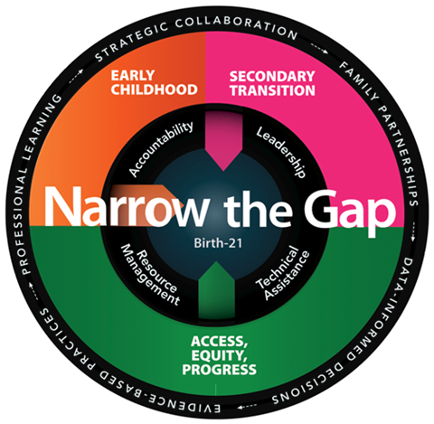
Strategic Plan:
Moving Maryland Forward
The Division of Early Intervention and Special Education Services is committed to Narrow the Gap between children and youth with disabilities and their non-disabled peers with the implementation of key measures of success and key strategies for implementation, through the use of innovative tools and resources.

Maryland Elevates Grant: Early Childhood Developmental Delays and Disabilities
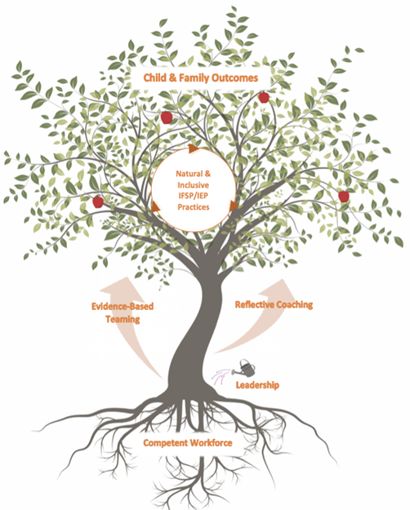

Early Childhood: Coordinated Services Implemented in Natural & Inclusive Environments
A seamless and comprehensive statewide system of early intervening supports and evidence-based practices provided to children with disabilities – birth to kindergarten – improves outcomes for children and their families.

Table of Contents
Cover Page (1-page limit) 4
Project Abstract (1-page limit) 5
Statement of Need 5
Evidence of Impact 5
Goals, Outcomes, and Strategies 6
Benchmarks 6
Project Narrative 6
Project Timeline 7
Implementation Team 7
Evaluation and Dissemination Plan 8
Accessibility Plan 8
General Education Provisions Act (GEPA), Section 427 8
Reporting Requirements 9
Budget and Budget Narrative 9
1. Salaries & Wages (list each position separately) 9
2. Contracted Services 10
3. Supplies & materials 10
4. Other charges 11
5. Equipment 11
6. Transfers (indirect costs) 12
Appendix 12

Instructions
Complete this application electronically by typing directly into the fillable fields and charts. Do not alter or remove sections. When finished, save the application document as a pdf to your computer and obtain appropriate signatures. The completed application should be saved as a pdf an emailed to DEI-SES-grant.submissions@Maryland.gov.

Cover Page (1-page limit)
Name of applicant: Click or tap here to enter text.
Complete mailing address (as it appears in the SAM record – include 9-digit zip code):
Click or tap here to enter text.
Click or tap here to enter text.
Federal Employer ID number: Click or tap here to enter text.
UEI number: Click or tap here to enter text. Expiration date: Click or tap here to enter text.
Project Director name: Click or tap here to enter text. | Title: Click or tap here to enter text.
Email: Click or tap here to enter text. | Phone: Click or tap here to enter text.
Financial contact name: Click or tap here to enter text. | Title: Click or tap here to enter text.
Email: Click or tap here to enter text. | Phone: Click or tap here to enter text.
Grants Office contact name: Click or tap here to enter text. | Title: Click or tap here to enter text.
Email: Click or tap here to enter text. | Phone: Click or tap here to enter text.
Select the high-leverage strategy(ies) addressed in this application:

☐ Inclusive early childhood education
☐ Kindergarten readiness interventions
☐ Social Emotional Learning (SEL)

Amount requested: $
Insert a screenshot of the active SAM record status below:

[enter screenshot here]

___________________________________________________________ ________________________
Head of Agency Printed Name Title

___________________________________________________________ ________________________
Head of Agency Signature Date

Project Abstract (1-page limit)
Provide a summary of the project that includes a description of the root causes of the problem, as well as the impact of the proposed project as it related to one or more of the high-leverage strategies. Refer to the Grant Information Guide for guidance.
Type response here.

Statement of Need
Provide a description of the proposed activities and how they will address the problem, root cause factor(s) and result in improved outcomes for children and youth with disabilities, and their families and/or their service providers. Any proposed strategies must be evidence-based practices (EBP) and include specific references to research supporting plan implementation. Refer to the Grant Information Guide for more detailed information and guidance.
Type response here.

Evidence of Impact
Provide a detailed description of the proposed activities and how they will address the problem, root cause factor(s) and result in improved outcomes for families of children with disabilities (birth through 21), educators, and service providers. Proposed strategies must be evidence-based practices (EBP) and include specific references to research supporting plan implementation. Refer to the Grant Information Guide for requirements.
Type response here.
Describe the applicant’s history and capacity to complete the proposed work.
Type response here.

Goals, Outcomes, and Strategies
Provide at least one project goal, with measurable outcomes and evidence-based strategies. Refer to the Grant Information Guide for guidance.
Goal #1: Click or tap here to enter text.
Measurable Outcome: Click or tap here to enter text.
Evidence-based Strategy: Click or tap here to enter text.
*Add more rows if necessary

Benchmarks
Provide benchmarks to measure progress towards meeting the goal(s) and objectives).
Benchmark / Outcome: How will it be known that progress is made? | Data: What data will be used to measure progress? | Frequency: How often will benchmark data be collected? | Evaluator: Who is responsible for conducting the evaluation?
Click or tap here to enter text. | Click or tap here to enter text. | Click or tap here to enter text. | Click or tap here to enter text.
Click or tap here to enter text. | Click or tap here to enter text. | Click or tap here to enter text. | Click or tap here to enter text.
Click or tap here to enter text. | Click or tap here to enter text. | Click or tap here to enter text. | Click or tap here to enter text.
*Add more rows if necessary

Project Narrative
Provide a description of the proposed activities. Any proposed strategies must be evidence-based practices (EBP) and include specific references to research supporting plan implementation.
Type response here.

Project Timeline
Complete the project timeline below. Be sure to include all key management, implementation, and evaluation activities.
Key Activities | Individual Responsible | Date of Implementation
Management Activity
Click or tap here to enter text. | Click or tap here to enter text. | Click or tap here to enter text.
Click or tap here to enter text. | Click or tap here to enter text. | Click or tap here to enter text.
Implementation Activity
Click or tap here to enter text. | Click or tap here to enter text. | Click or tap here to enter text.
Click or tap here to enter text. | Click or tap here to enter text. | Click or tap here to enter text.
Evaluation Activity
Click or tap here to enter text. | Click or tap here to enter text. | Click or tap here to enter text.
*Add more rows if necessary

Implementation Team
Identify the implementation team including names, titles, roles, and responsibilities relative to plan implementation. Attach a resume or curriculum vitae for each key personnel.
Name | Title | Roles & Responsibilities
Click or tap here to enter text. | Click or tap here to enter text. | Click or tap here to enter text.
Click or tap here to enter text. | Click or tap here to enter text. | Click or tap here to enter text.
Click or tap here to enter text. | Click or tap here to enter text. | Click or tap here to enter text.
*Add more rows if necessary

Evaluation and Dissemination Plan
Describe the plan to evaluate the program’s goals and objectives, and how success will be measured. Refer to the Grant Information Guide for guidance. Refer to the Grant Information Guide for more detailed information and guidance.
Type response here.
Evaluation is an important part of determining the success of the program. Applicants are required to describe in detail what success will look like and the criteria that will be used to determine and measure success. Describe the evaluation plan and how the applicant will determine that the proposed activities were successful.
Type response here.
Describe how the project and the evaluation results will be communicated to major stakeholders and individuals interested in the project.
Type response here.

Accessibility Plan
Describe how the application will ensure that the projects offering paper, web or technology-based instructional products or programs operate in compliance with Section 508 of the Federal Rehabilitation Act of 1973.
Type response here.

General Education Provisions Act (GEPA), Section 427
Explain the steps the applicant will take to ensure equitable access to and participation in the project as it is related to the six (6) types of barriers described in the GEPA (gender, race, national origin, color, disability, and age).
Type response here.

Reporting Requirements
Grantees must comply with the following reporting requirements:
Date | Reporting Requirements | Person Responsible
Jan 31, 2023 | Interim Cumulative Variance and Programmatic Progress Report | Click or tap here to enter text.
October 1, 2022 – November 30, 2023 | Monthly Invoice | Click or tap here to enter text.
Aug 15, 2023 | Deadline for the submission of any requests for grant amendment | Click or tap here to enter text.
Nov 30, 2023 | Final Cumulative Variance and Programmatic Progress Report;  Final Financial Report (inclusive of all liquidations as of 9/30/2023); and  Final Invoice | Click or tap here to enter text.

Budget and Budget Narrative
Please provide a detailed description of the requested funds that will be spent by using the categories listed below. Add more rows if needed. An MSDE Grant Budget C-125 and Budget Detail form must also be completed, signed and submitted as an appendix.

1. Salaries & Wages (list each position separately)
Line item | Calculation | Requested | In-Kind | Total
Enter text here. | Enter text here. | $Enter figure here. | $Enter figure here. | $Enter figure here.
Enter text here. | Enter text here. | $Enter figure here. | $Enter figure here. | $Enter figure here.
 | Total for salaries & wages: | $Enter figure here. | $Enter figure here. | $Enter figure here.
Using the space below, explain how the costs for salaries & wages above are necessary, reasonable, and cost-effective.
Type response here.

2. Contracted Services
Line item | Calculation | Requested | In-Kind | Total
Enter text here. | Enter text here. | $Enter figure here. | $Enter figure here. | $Enter figure here.
Enter text here. | Enter text here. | $Enter figure here. | $Enter figure here. | $Enter figure here.
 | Total for contracted services: | $Enter figure here. | $Enter figure here. | $Enter figure here.
Using the space below, explain how the costs for contracted services above are necessary, reasonable, and cost-effective.
Type response here.

3. Supplies & materials
Line item | Calculation | Requested | In-Kind | Total
Enter text here. | Enter text here. | $Enter figure here. | $Enter figure here. | $Enter figure here.
Enter text here. | Enter text here. | $Enter figure here. | $Enter figure here. | $Enter figure here.
 | Total supplies & materials: | $Enter figure here. | $Enter figure here. | $Enter figure here.
Using the space below, explain how the costs for supplies & materials above are necessary, reasonable, and cost-effective.
Type response here.

4. Other charges
Line item | Calculation | Requested | In-Kind | Total
Enter text here. | Enter text here. | $Enter figure here. | $Enter figure here. | $Enter figure here.
Enter text here. | Enter text here. | $Enter figure here. | $Enter figure here. | $Enter figure here.
 | Total for other charges: | $Enter figure here. | $Enter figure here. | $Enter figure here.
Using the space below, explain how the costs for other charges above are necessary, reasonable, and cost-effective.
Type response here.

5. Equipment
Line item | Calculation | Requested | In-Kind | Total
Enter text here. | Enter text here. | $Enter figure here. | $Enter figure here. | $Enter figure here.
Enter text here. | Enter text here. | $Enter figure here. | $Enter figure here. | $Enter figure here.
 | Total for equipment: | $Enter figure here. | $Enter figure here. | $Enter figure here.
Using the space below, explain how the costs for equipment above are necessary, reasonable, and cost-effective.
Type response here.

6. Transfers (indirect costs)
Line item | Calculation | Requested | In-Kind | Total
Enter text here. | Enter text here. | $Enter figure here. | $Enter figure here. | $Enter figure here.
Enter text here. | Enter text here. | $Enter figure here. | $Enter figure here. | $Enter figure here.
 | Total for transfers: | $Enter figure here. | $Enter figure here. | $Enter figure here.
Using the space below, explain how the costs for transfers (indirect costs) above are necessary, reasonable, and cost-effective.
Type response here.
Total amount requested: $ Enter total here.
Total in-kind funding: $ Enter total here.

Appendix
- A signed Recipient Assurances page
- A signed Non-LEA/IHE Certification page
- A signed certifications page regarding Lobbying, Debarment, Suspension, other responsibility matters, and Drug-free Workplace
- A signed C-1-25 MSDE budget form and Budget Detail
- Letters of support from any partners
- One-page resumes of key personnel
- A copy of the W-9 Form (Applicable for first time grant applicants and/or grantees requiring a change of address/contact)

